#### **Course Description**

#### In this course, you will take a deeper dive into the wide range of data formats out there. More specifically, you will learn how to import data from relational databases and how to import and work with data coming from the web. Finally, you will get hands-on experience with importing data from statistical software packages such as SAS, STATA, and SPSS.

#### **Importing data from databases (Part 1)**

Many companies store their information in relational databases. The R community has also developed R packages to get data from these architectures. You will learn how to connect to a database and how to retrieve data from it.

# Establish a connection

The first step to import data from a SQL database is creating a connection to it. You need different packages depending on the database you want to connect to. All these packages do this in a uniform way, as specified in the DBI package.

[**dbConnect()**](http://www.rdocumentation.org/packages/DBI/functions/dbConnect) creates a connection between your R session and a SQL database. The first argument must be a DBIdriver object, that specifies how connections are made and how data is mapped between R and the database. Specifically for MySQL databases, you can build such a driver with [**RMySQL::MySQL()**](http://www.rdocumentation.org/packages/RMySQL/functions/MySQLDriver-class).

If the MySQL database is a remote database hosted on a server, you'll also have to specify the following arguments in [**dbConnect()**](http://www.rdocumentation.org/packages/DBI/functions/dbConnect): dbname, host, port, user and password. Most of these details have already been provided.

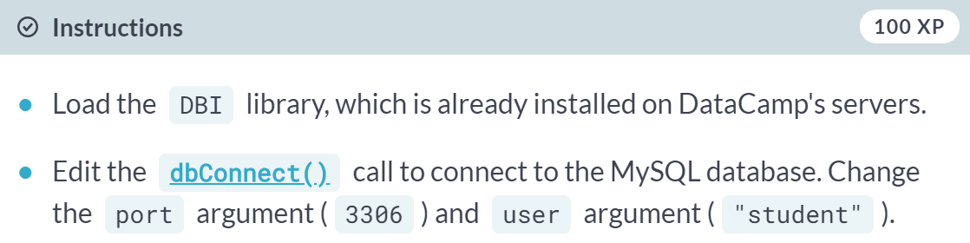  
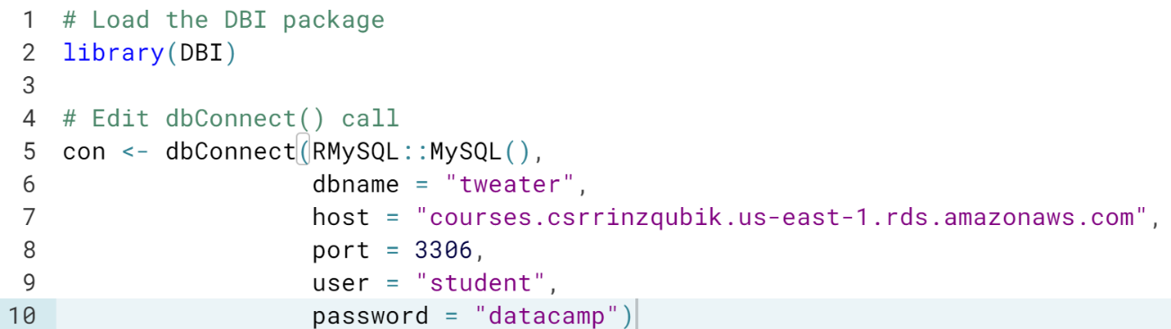  
Awesome! You are now connected to the MySQL database.

# Inspect the connection

Now that you have successfully created the database connection, let's have a closer look at it. With the object con available in your workspace, can you tell which of the following statements is true?

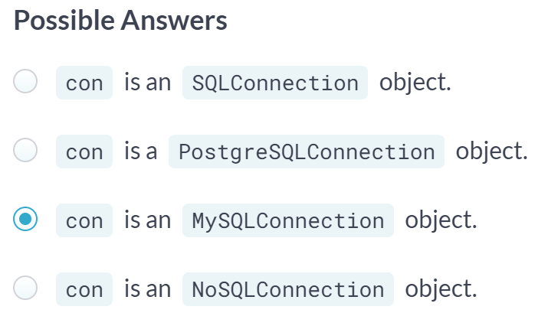

# List the database tables

After you have successfully connected to a remote MySQL database, the next step is to see what tables the database contains. You can do this with the [**dbListTables()**](http://www.rdocumentation.org/packages/DBI/functions/dbListTables) function. As you might remember from the video, this function requires the connection object as an input, and outputs a character vector with the table names.

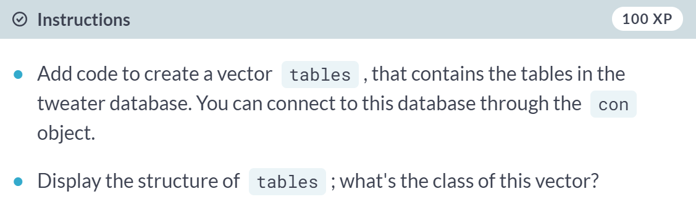

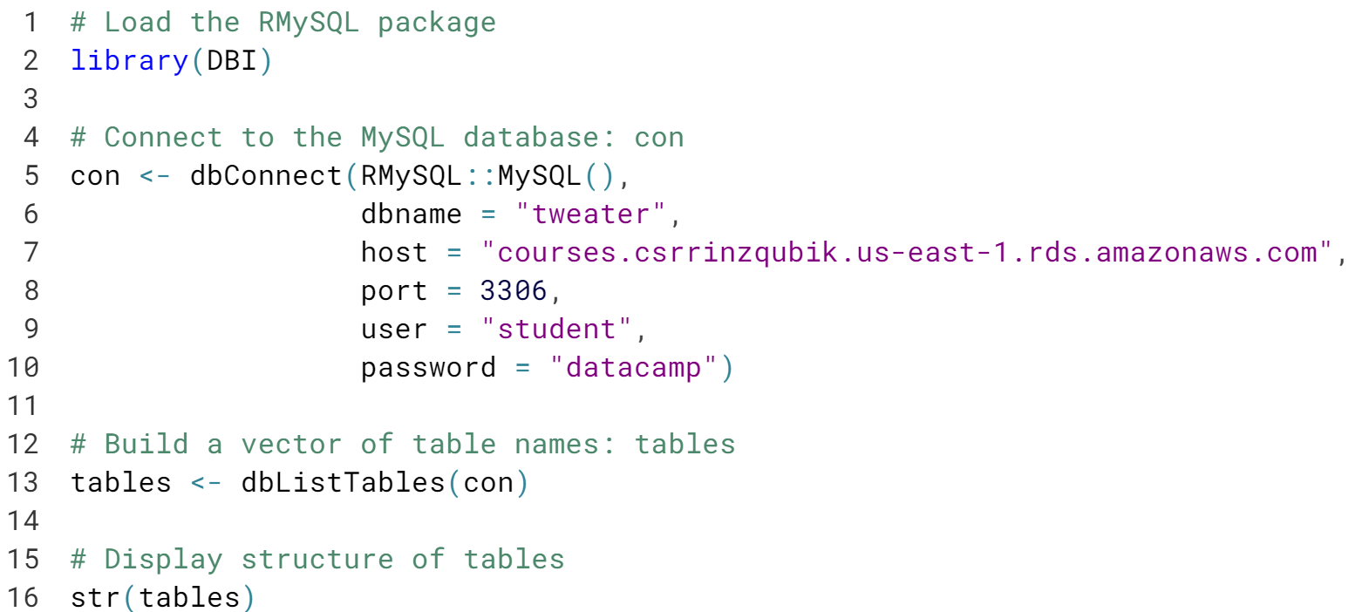

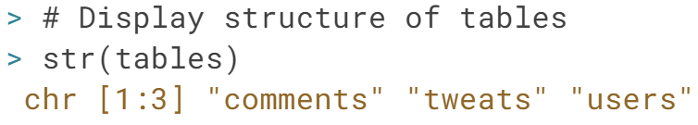

Good! ***dbListTables()*** can be very useful to get a first idea about the contents of your database.

# Import users

As you might have guessed by now, the database contains data on a tastier version of Twitter, namely Tweater. Users can post tweats with short recipes for delicious snacks. People can comment on these tweats. There are three tables: **users**, **tweats**, and **comments** that have relations among them. Which ones, you ask? You will discover in a moment!

Let us start by importing the data on the users into your R session. You do this with the [**dbReadTable()**](http://www.rdocumentation.org/packages/DBI/functions/dbReadTable) function. Simply pass it the connection object (con), followed by the name of the table you want to import. The resulting object is a standard R data frame.

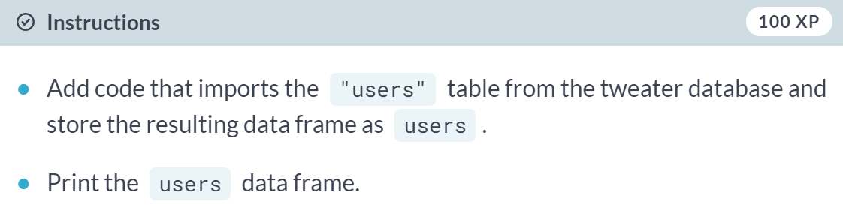

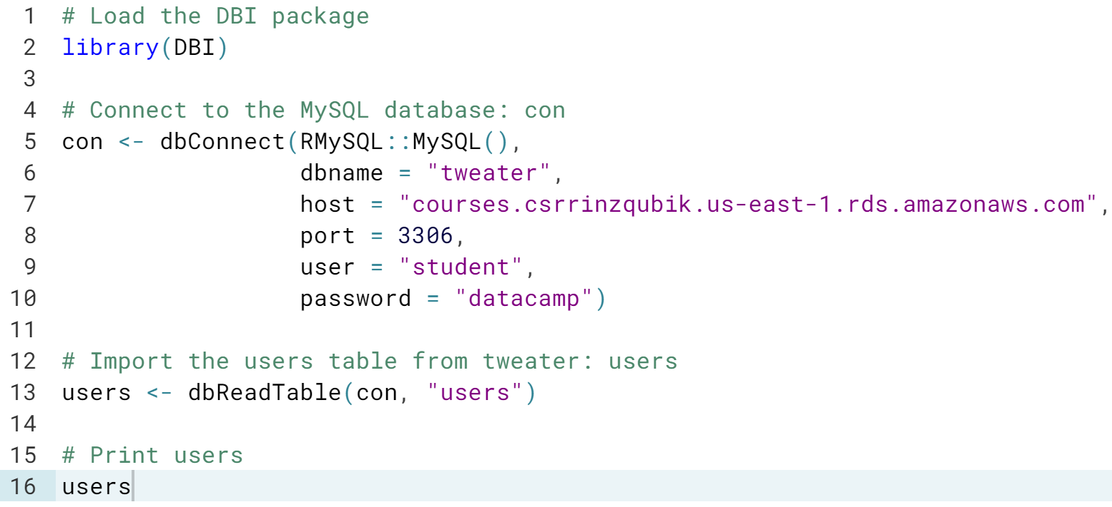

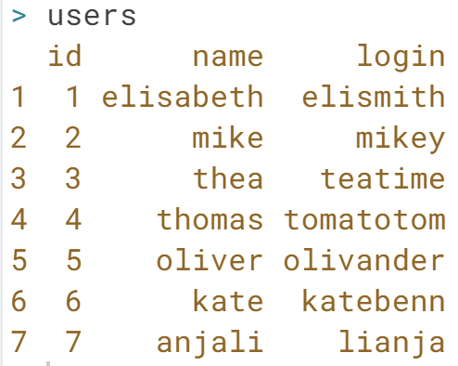

# Import all tables

Next to the users, we are also interested in the tweats and comments tables. However, separate dbReadTable() calls for each one of the tables in your database would mean a lot of code duplication. Remember about the lapply() function? You can use it again here! A connection is already coded for you, as well as a vector table\_names, containing the names of all the tables in the database.

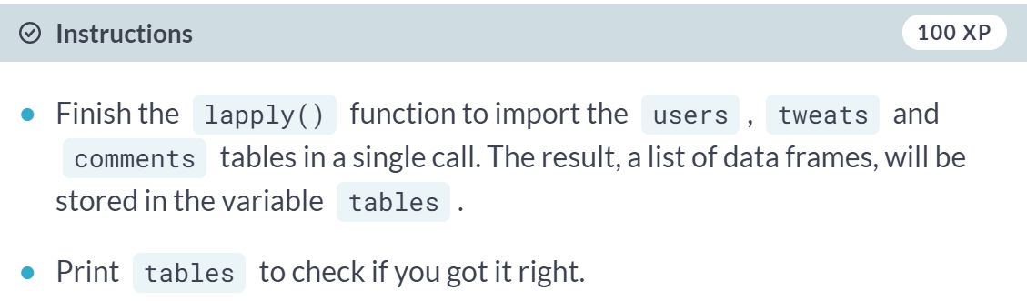

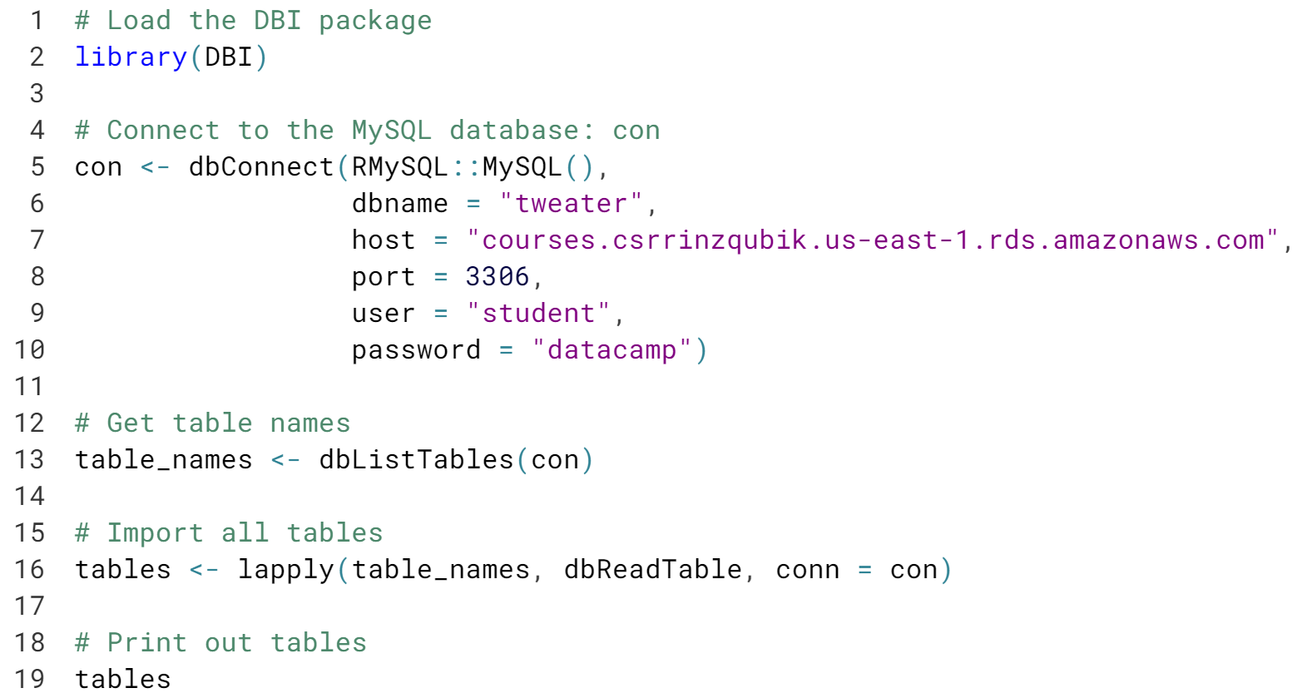

Wonderful! Now that you have an R version of all data that is contained in the database, you can dive a little deeper into the relations between the different data frames.

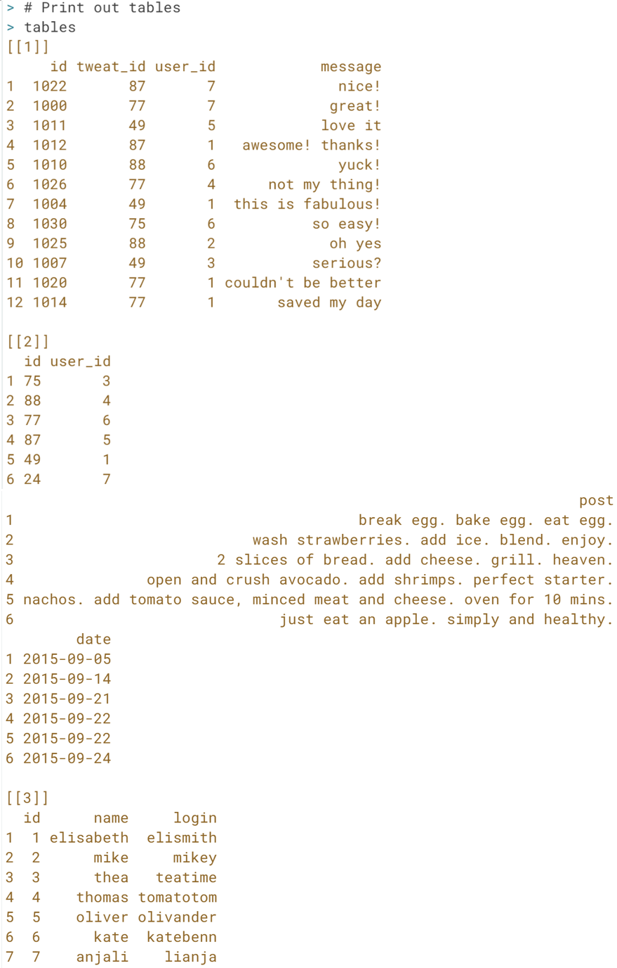

# How do the tables relate?

The connection to the MySQL database con has already been created for you. tables, a list containing the three tables as data frames that you have created in the previous exercise, is also available.

If you have a closer look at these tables, you will see that the tweats table, for example, contains a column user\_id. The ids in the column refer to the users that have posted the tweat. Similarly, the comments contain both a user\_id and a tweat\_id column. It specifies which user posted a comment on which tweat.

With this new knowledge, can you tell **who** posted the **tweat** on which somebody **commented** "awesome! thanks!" (comment 1012)?

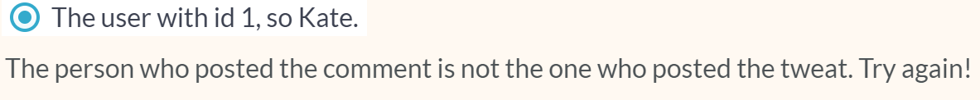

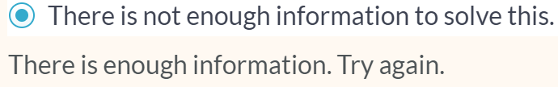



#### **Importing data from databases (Part 2)**

Importing an entire table from a database while you might only need a tiny bit of information seems like a lot of unnecessary work. In this chapter, you will learn about SQL queries, which will help you make things more efficient by performing some computations on the database side.

# Query tweater (1)

In your life as a data scientist, you'll often be working with huge databases that contain tables with millions of rows. If you want to do some analyses on this data, it's possible that you only need a fraction of this data. In this case, it's a good idea to send SQL queries to your database, and only import the data you actually need into R.

[**dbGetQuery()**](http://www.rdocumentation.org/packages/DBI/functions/dbGetQuery) is what you need. As usual, you first pass the connection object to it. The second argument is an SQL query in the form of a character string. This example selects the age variable from the people dataset where gender equals "male":

dbGetQuery(con, "SELECT age FROM people WHERE gender = 'male'")

A connection to the tweater database has already been coded for you.

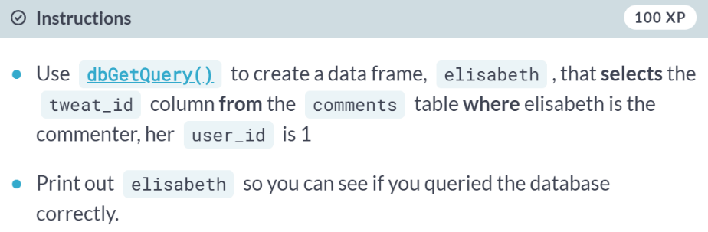  
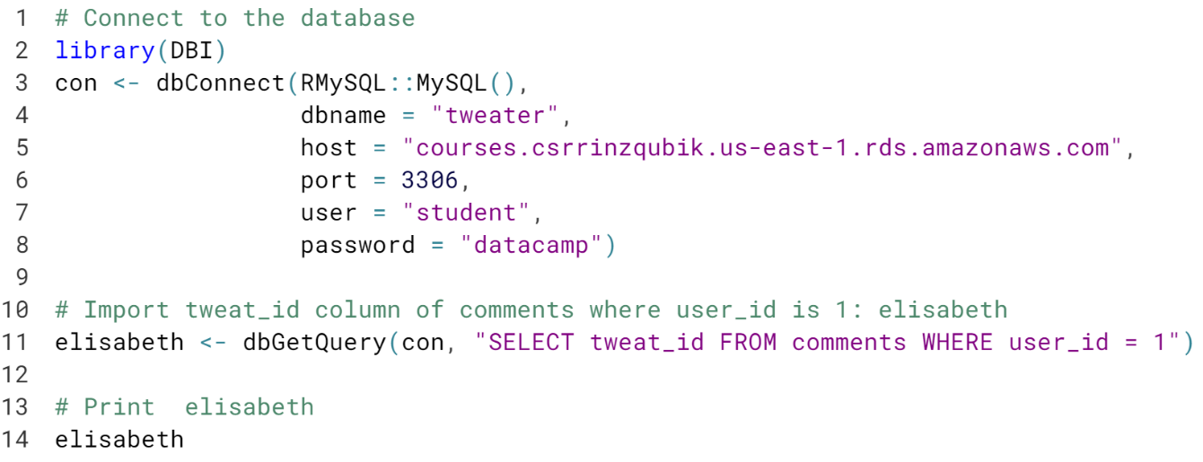  
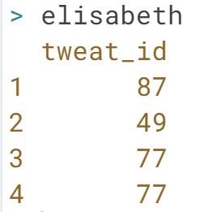

# Query tweater (2)

Apart from checking equality, you can also check for less than and greater than relationships, with < and >, just like in R.

con, a connection to the tweater database, is again available.

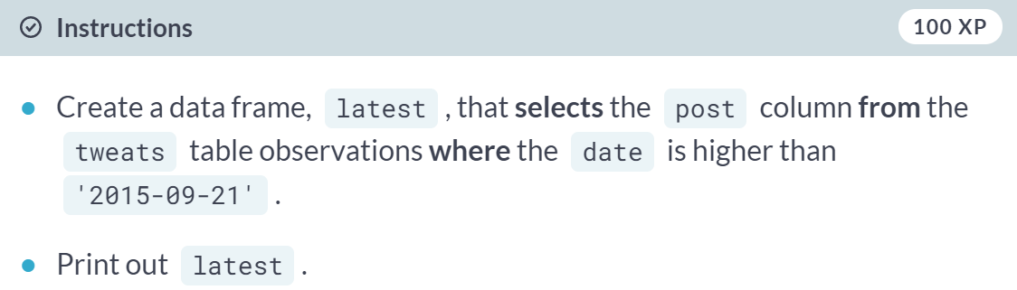

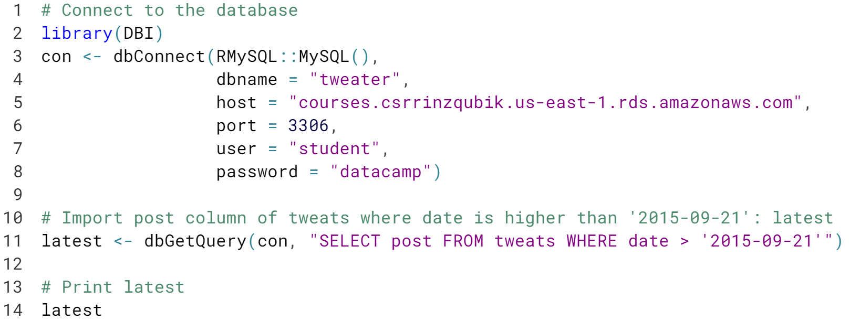

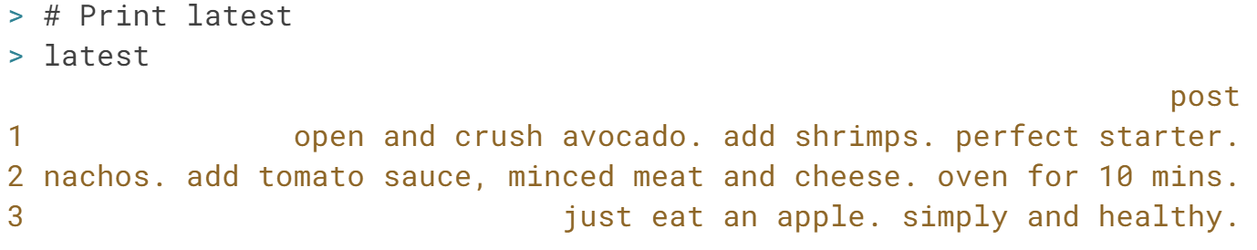

# Query tweater (3)

Suppose that you have a people table, with a bunch of information. This time, you want to find out the age and country of married males. Provided that there is a married column that is 1 when the person in question is married, the following query would work.

SELECT age, country

FROM people

WHERE gender = "male" AND married = 1

Can you use a similar approach for a more specialized query on the tweater database?

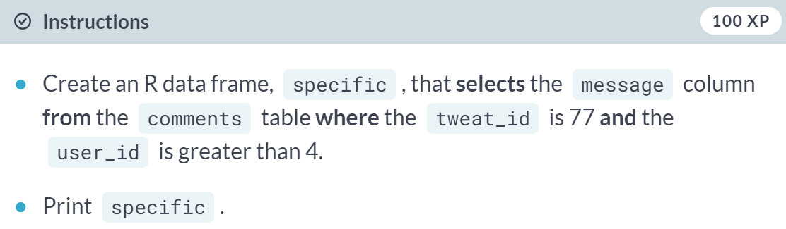

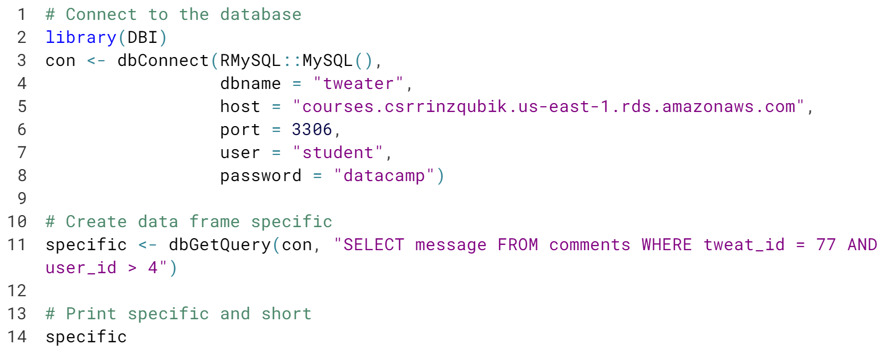

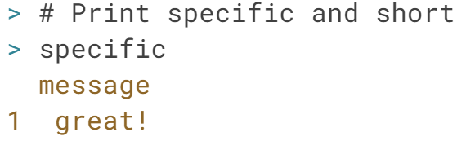

# Query tweater (4)

There are also dedicated SQL functions that you can use in the WHERE clause of an SQL query. For example, CHAR\_LENGTH() returns the number of characters in a string.

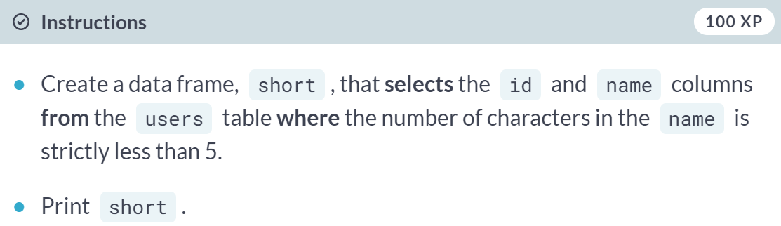

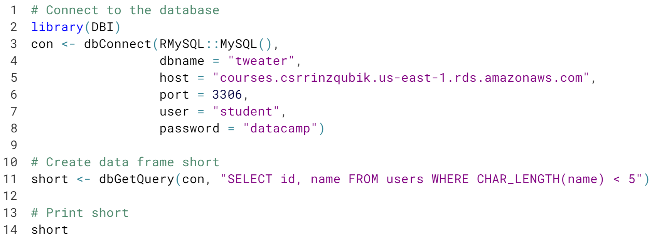

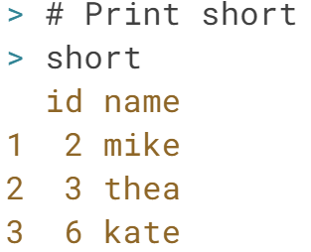

# Join the query madness!

Of course, SQL does not stop with the the three keywords SELECT, FROM and WHERE. Another very often used keyword is JOIN, and more specifically INNER JOIN. Take this call for example:

SELECT name, post

FROM users INNER JOIN tweats on users.id = user\_id

WHERE date > "2015-09-19"

Here, the users table is joined with the tweats table. This is possible because the id column in the users table corresponds to the user\_id column in the tweats table. Also notice how name, from the users table, and post and date, from the tweats table, can be referenced to without problems.

Can you predict the outcome of the following query?

SELECT post, message

FROM tweats INNER JOIN comments on tweats.id = tweat\_id

WHERE tweat\_id = 77

A connection to the tweater database is already available as con; feel free to experiment!

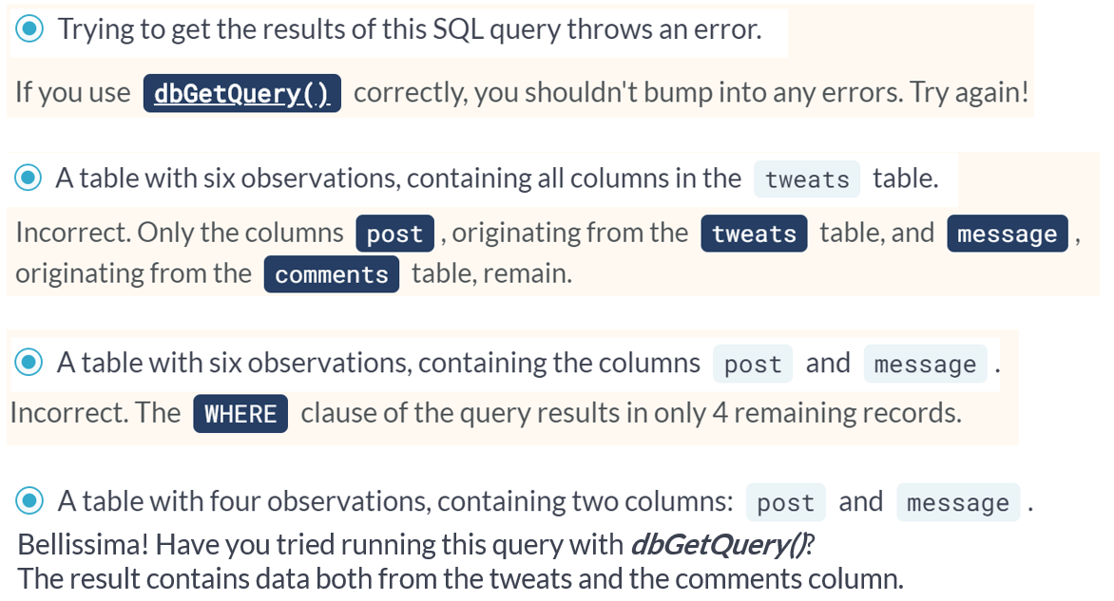

# Send - Fetch - Clear

You've used [**dbGetQuery()**](http://www.rdocumentation.org/packages/DBI/functions/dbGetQuery) multiple times now. This is a virtual function from the DBI package, but is actually implemented by the RMySQL package. Behind the scenes, the following steps are performed:

* Sending the specified query with [**dbSendQuery()**](http://www.rdocumentation.org/packages/DBI/functions/dbSendQuery);
* Fetching the result of executing the query on the database with [**dbFetch()**](http://www.rdocumentation.org/packages/DBI/functions/dbFetch);
* Clearing the result with [**dbClearResult()**](http://www.rdocumentation.org/packages/DBI/functions/dbClearResult).

Let's not use [**dbGetQuery()**](http://www.rdocumentation.org/packages/DBI/functions/dbGetQuery) this time and implement the steps above. This is tedious to write, but it gives you the ability to fetch the query's result in chunks rather than all at once. You can do this by specifying the n argument inside **[dbFetch()](http://www.rdocumentation.org/packages/DBI/functions/dbFetch" \t "_blank)**.

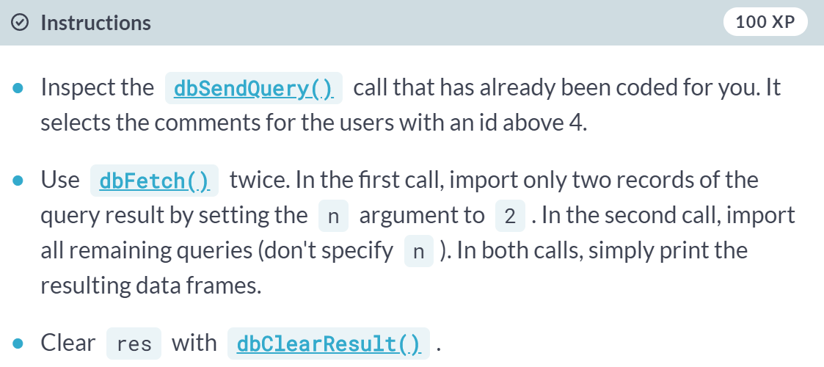

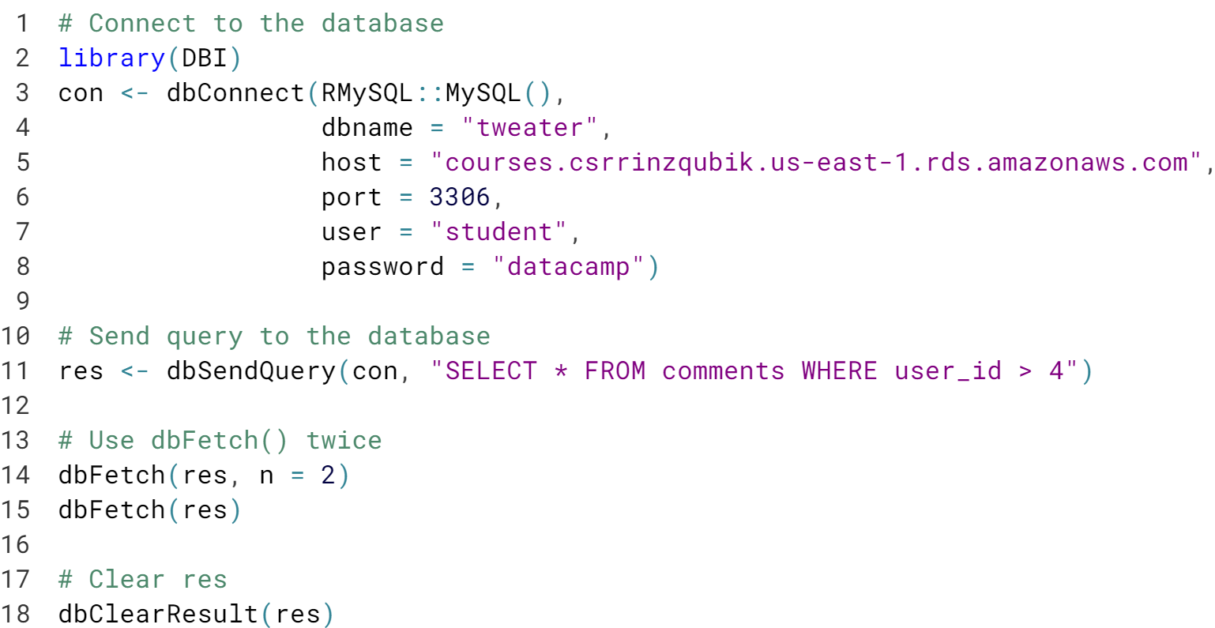

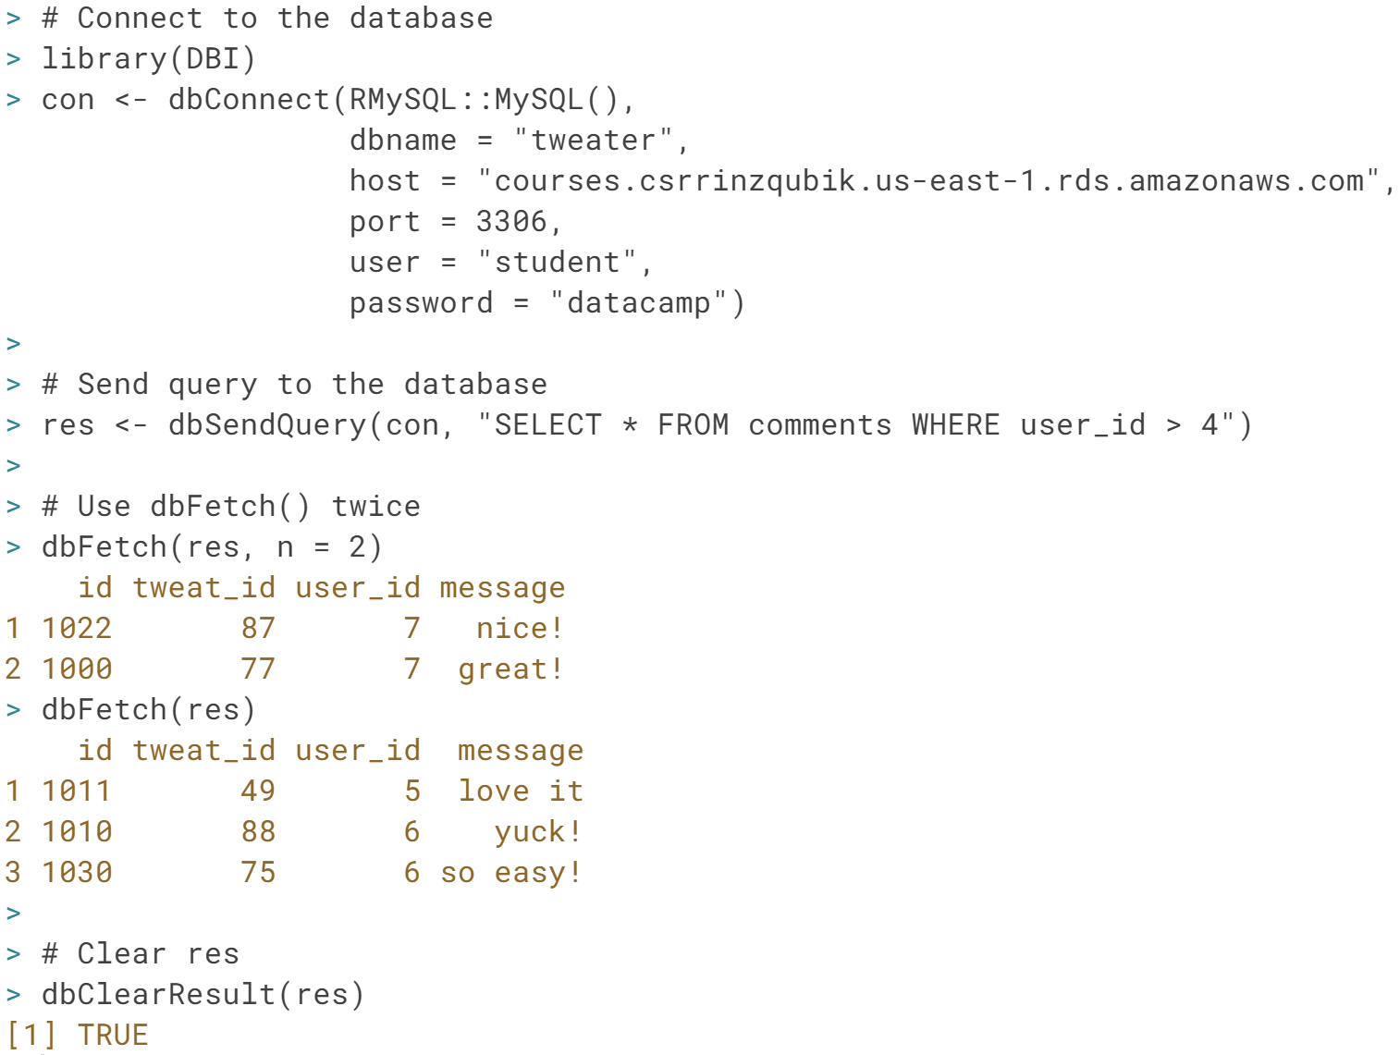

Perfect! In this example, chopping up the fetches does not make a lot of sense, but whole point of doing this exercise is to remember this technique when you're struggling with huge databases!

# Be polite and ...

Every time you connect to a database using [**dbConnect()**](http://www.rdocumentation.org/packages/DBI/functions/dbConnect), you're creating a new connection to the database you're referencing. RMySQL automatically specifies a maximum of open connections and closes some of the connections for you, but still: it's always polite to manually disconnect from the database afterwards. You do this with the [**dbDisconnect()**](http://www.rdocumentation.org/packages/DBI/functions/dbDisconnect) function.

The code that connects you to the database is already available, can you finish the script?

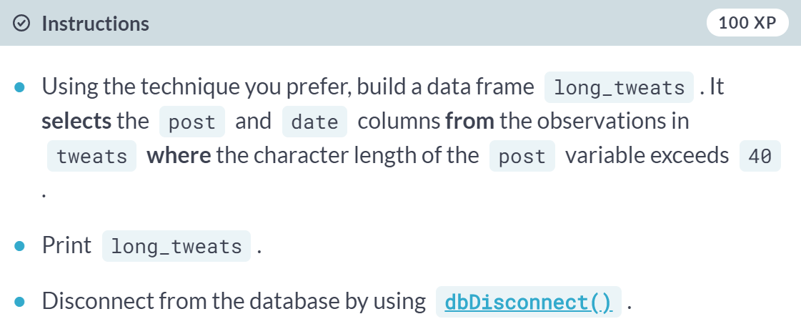

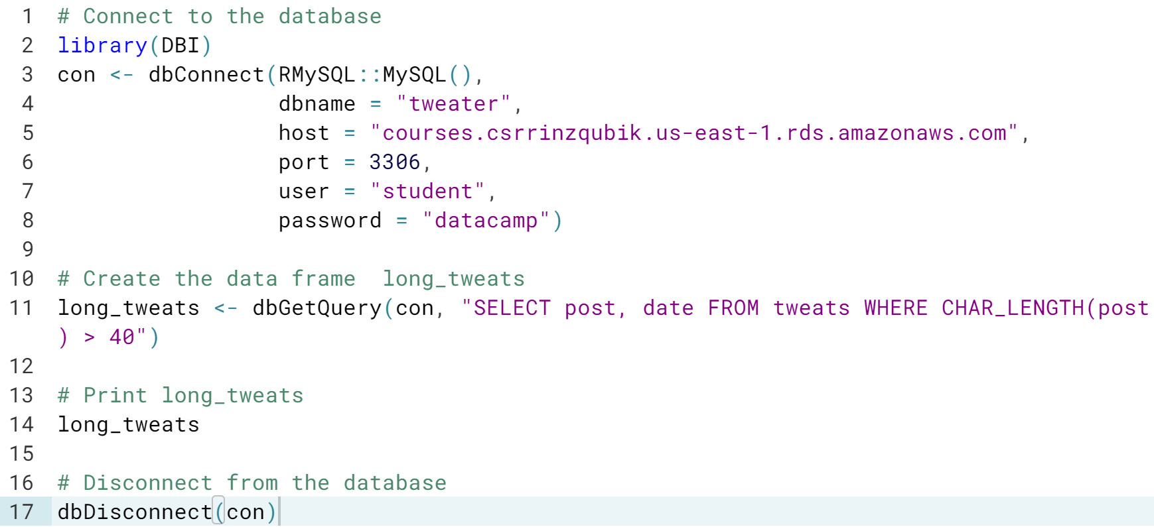

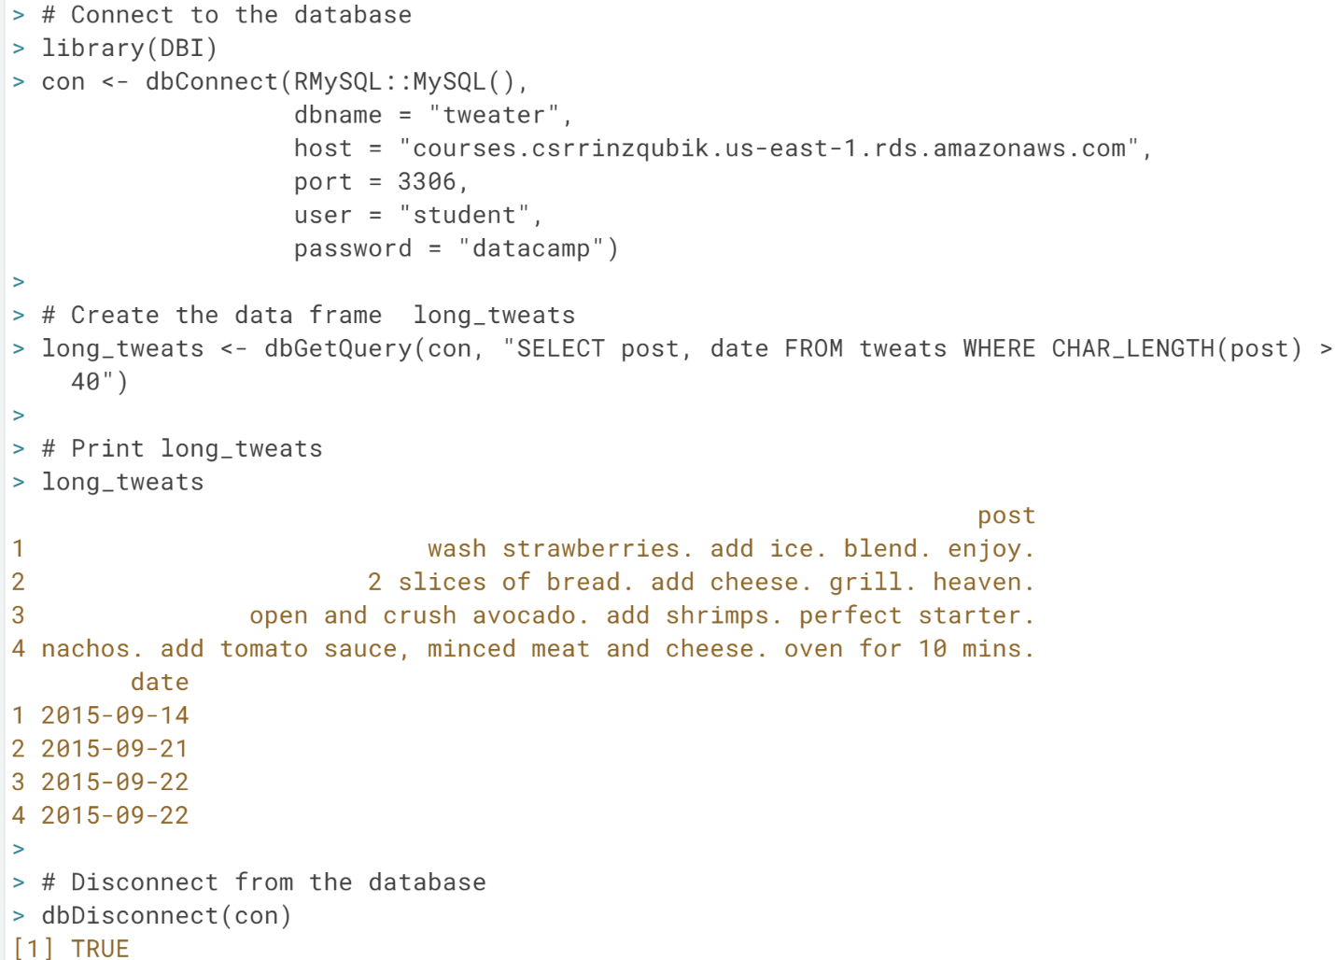

#### **Importing data from the web (Part 1)**

More and more of the information that data scientists are using resides on the web. Importing this data into R requires an understanding of the protocols used on the web. In this chapter, you'll get a crash course in HTTP and learn to perform your own HTTP requests from inside R.

# Import flat files from the web

In the video, you saw that the utils functions to import flat file data, such as [**read.csv()**](http://www.rdocumentation.org/packages/utils/functions/read.table) and [**read.delim()**](http://www.rdocumentation.org/packages/utils/functions/read.table), are capable of automatically importing from URLs that point to flat files on the web.

You must be wondering whether Hadley Wickham's alternative package, readr, is equally potent. Well, figure it out in this exercise! The URLs for both a .csv file as well as a .delim file are already coded for you. It's up to you to actually import the data. If it works, that is...

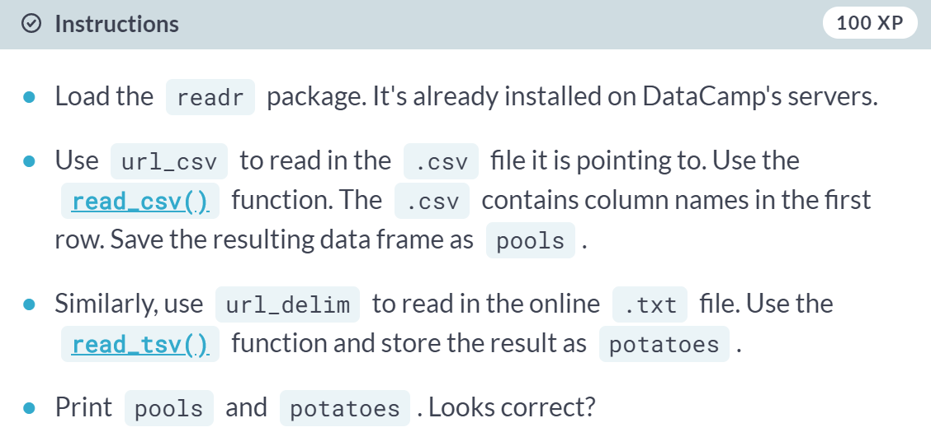

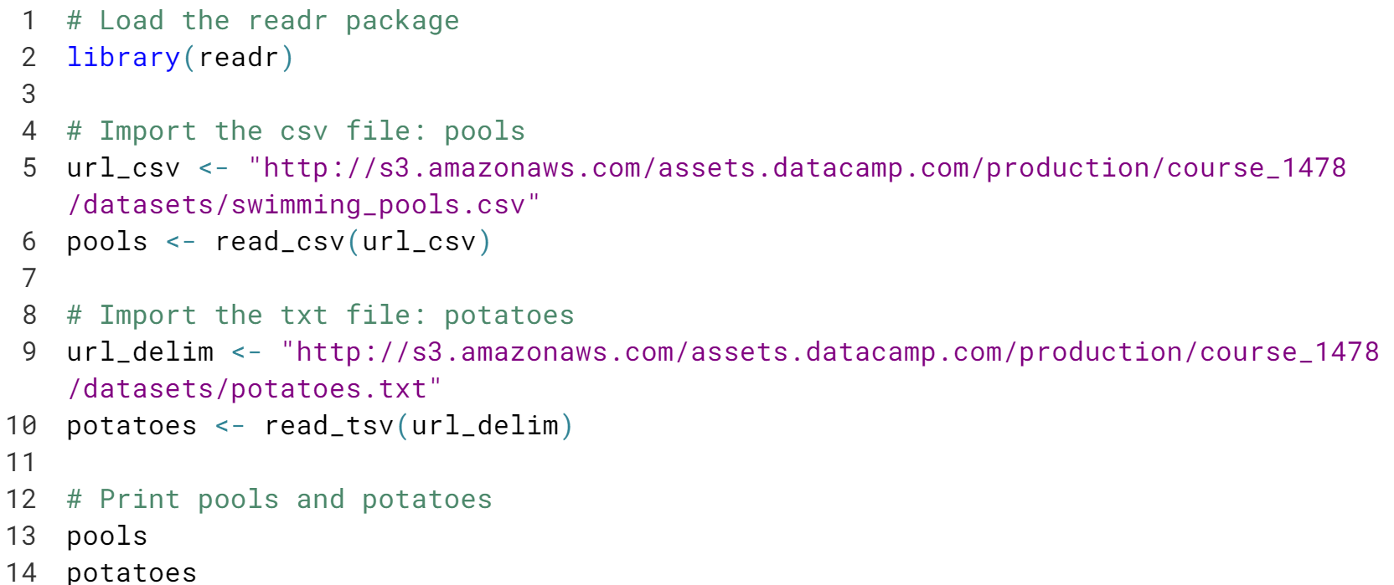

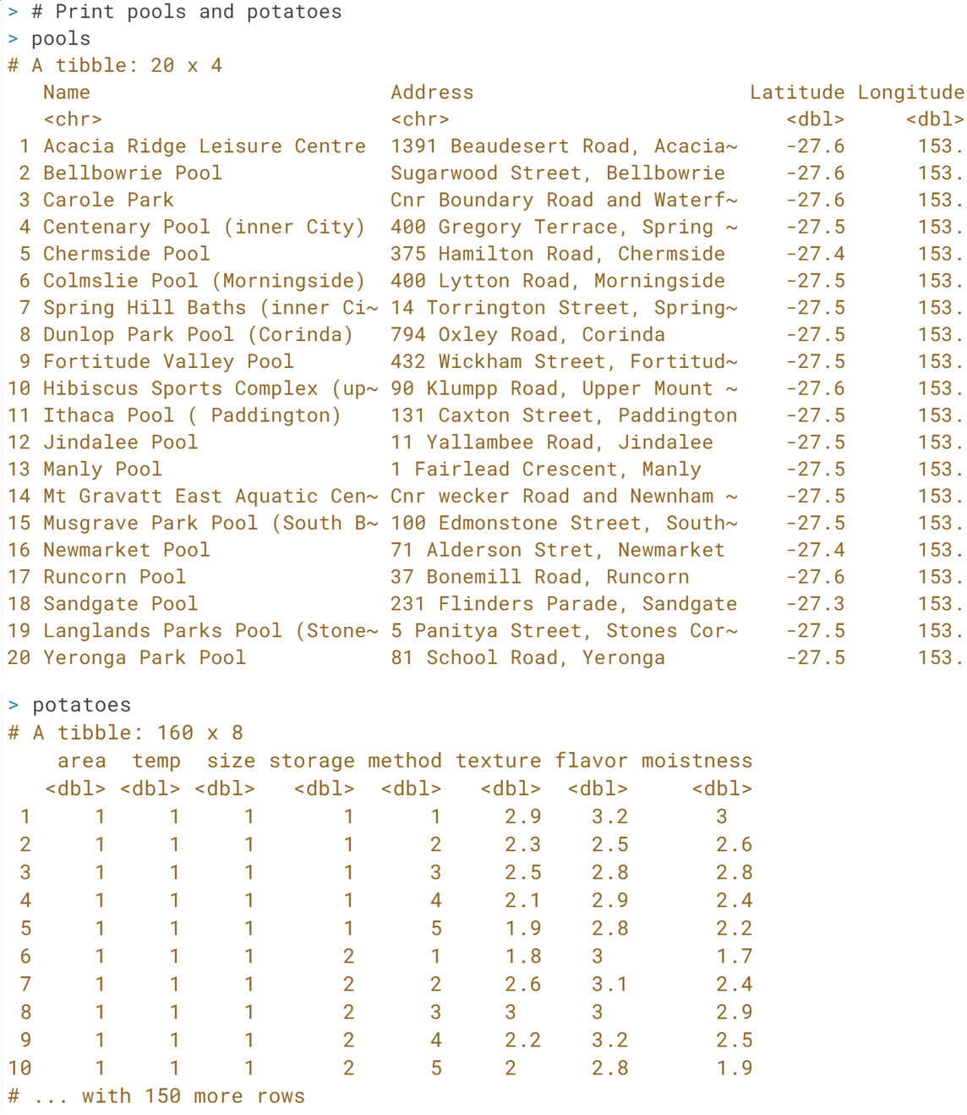

# Secure importing

In the previous exercises, you have been working with URLs that all start with http://. There is, however, a safer alternative to HTTP, namely HTTPS, which stands for Hypertext Transfer Protocol Secure. Just remember this: HTTPS is relatively safe, HTTP is not.

Luckily for us, you can use the standard importing functions with https:// connections since R version 3.2.2.

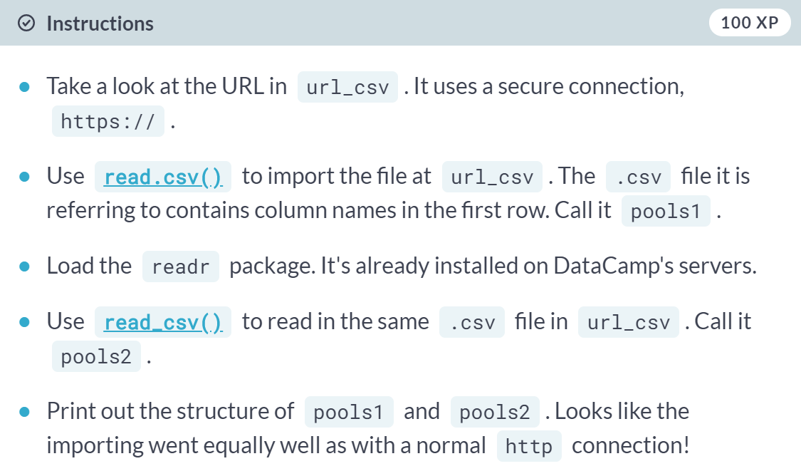

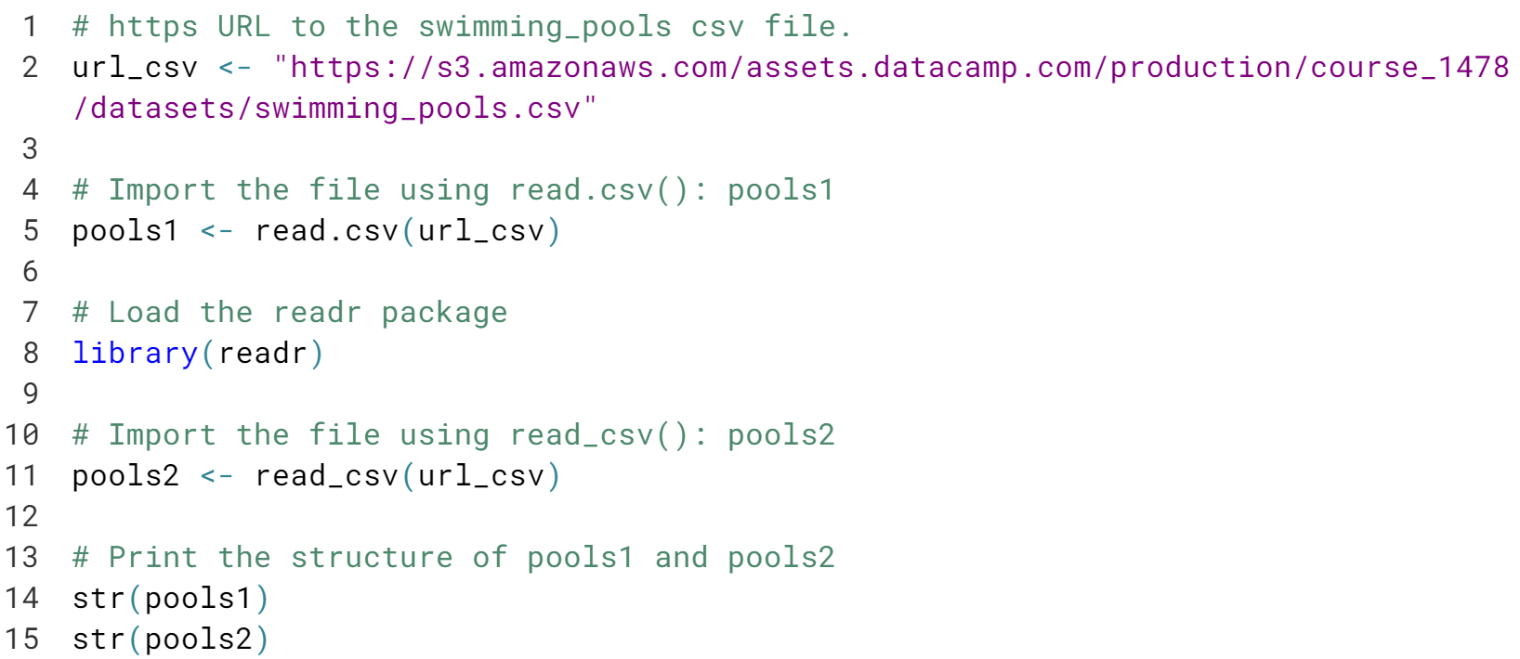

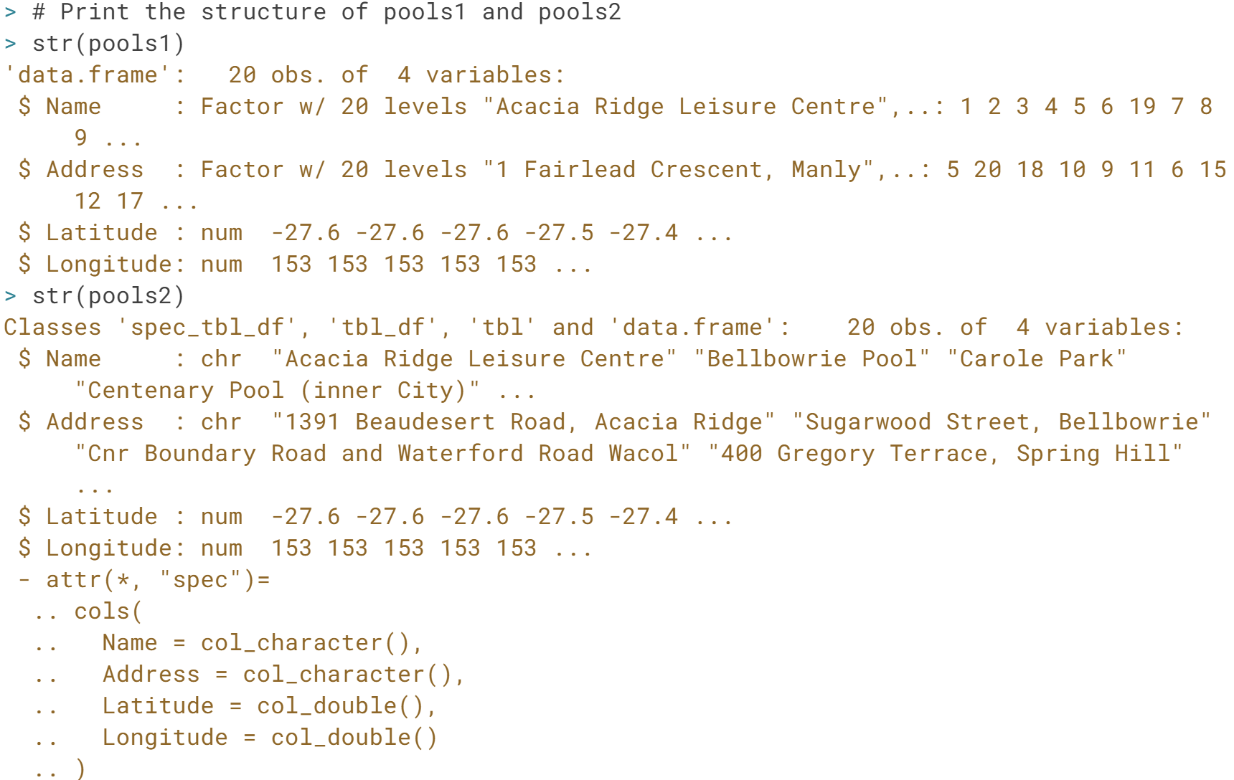

# Import Excel files from the web

When you learned about gdata, it was already mentioned that gdata can handle .xls files that are on the internet. readxl can't, at least not yet. The URL with which you'll be working is already available in the sample code. You will import it once using gdata and once with the readxl package via a workaround.

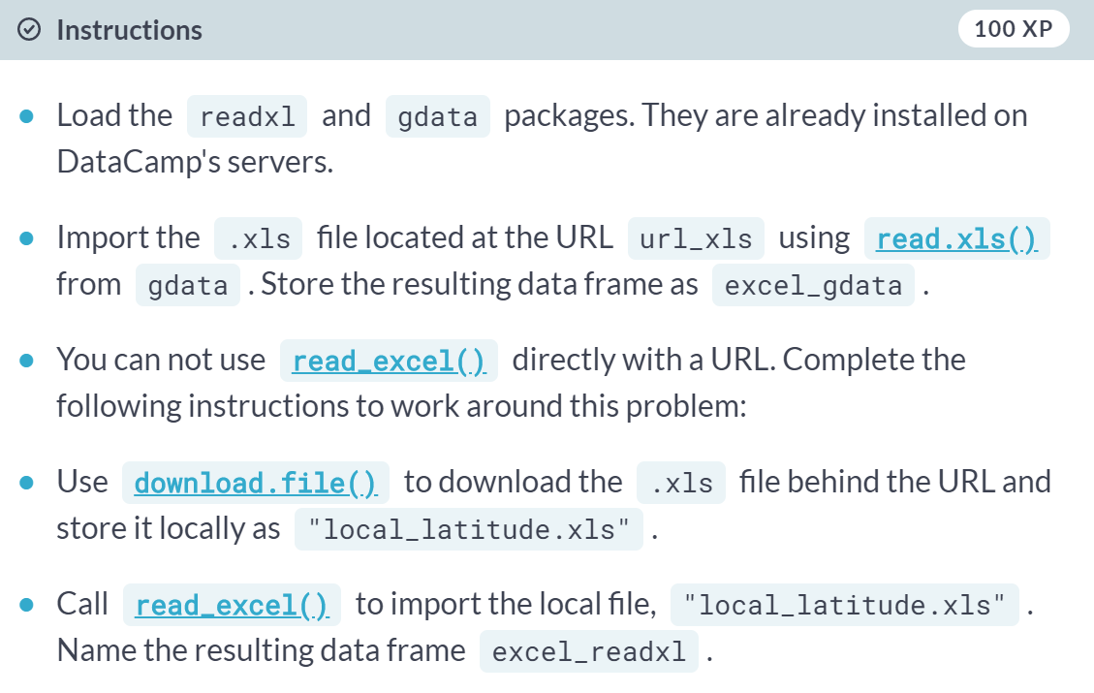

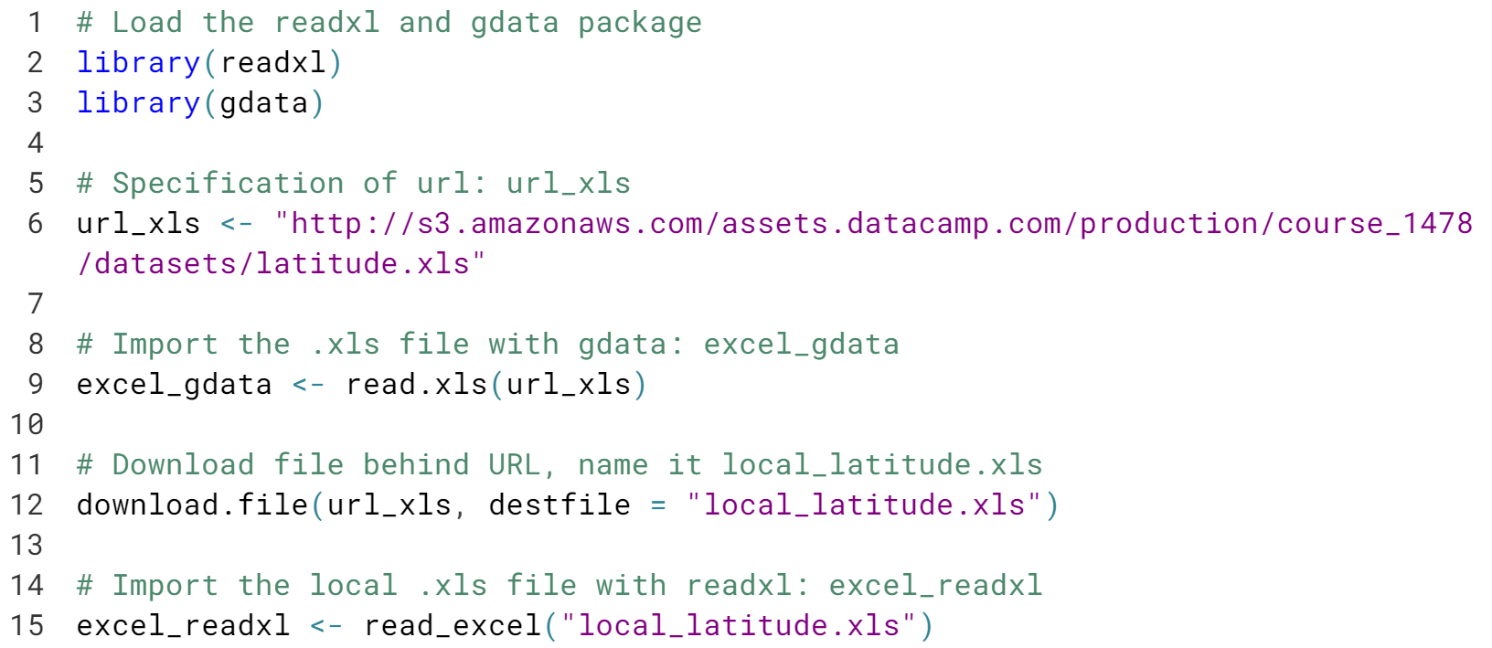

It appears that ***readxl*** is yet able to deal with Excel files that are on the web. However, a simply workaround with ***download.file()*** fixes this.

# Downloading any file, secure or not

In the previous exercise you've seen how you can read excel files on the web using the read\_excel package by first downloading the file with the [**download.file()**](http://www.rdocumentation.org/packages/utils/functions/download.file) function.

There's more: with [**download.file()**](http://www.rdocumentation.org/packages/utils/functions/download.file) you can download any kind of file from the web, using HTTP and HTTPS: images, executable files, but also .RData files. An RData file is very efficient format to store R data.

You can load data from an RData file using the [**load()**](http://www.rdocumentation.org/packages/base/functions/load) function, but this function does not accept a URL string as an argument. In this exercise, you'll first download the RData file securely, and then import the local data file.

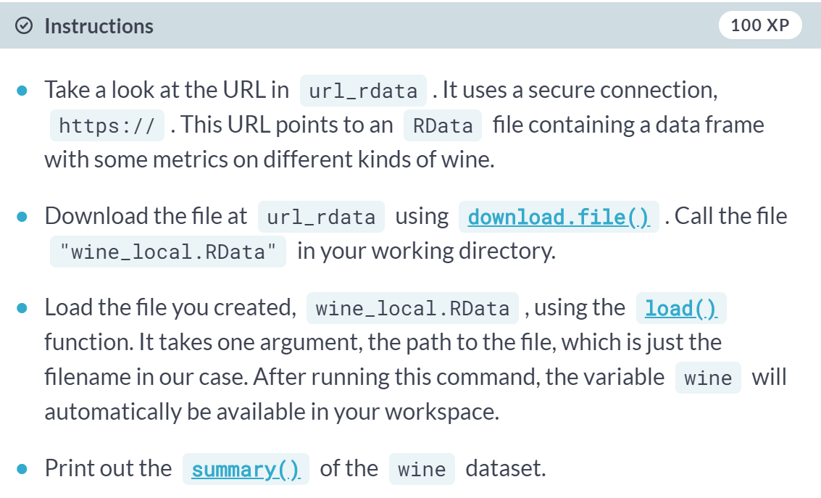

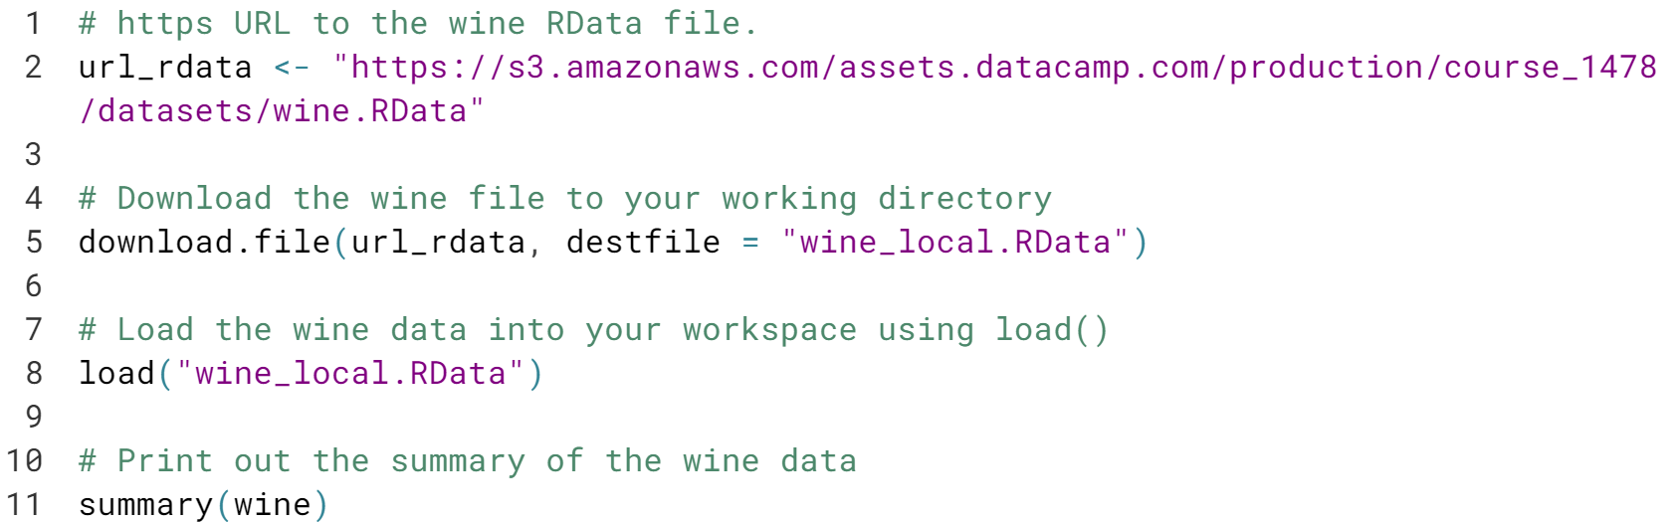

# Downloading any file, secure or not

In the previous exercise you've seen how you can read excel files on the web using the read\_excel package by first downloading the file with the [**download.file()**](http://www.rdocumentation.org/packages/utils/functions/download.file) function.

There's more: with [**download.file()**](http://www.rdocumentation.org/packages/utils/functions/download.file) you can download any kind of file from the web, using HTTP and HTTPS: images, executable files, but also .RData files. An RData file is very efficient format to store R data.

You can load data from an RData file using the [**load()**](http://www.rdocumentation.org/packages/base/functions/load) function, but this function does not accept a URL string as an argument. In this exercise, you'll first download the RData file securely, and then import the local data file.

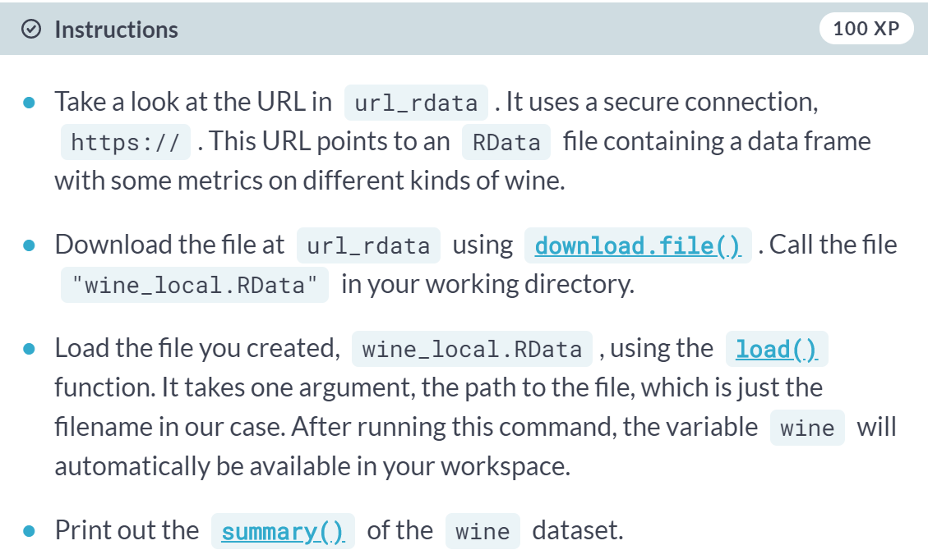

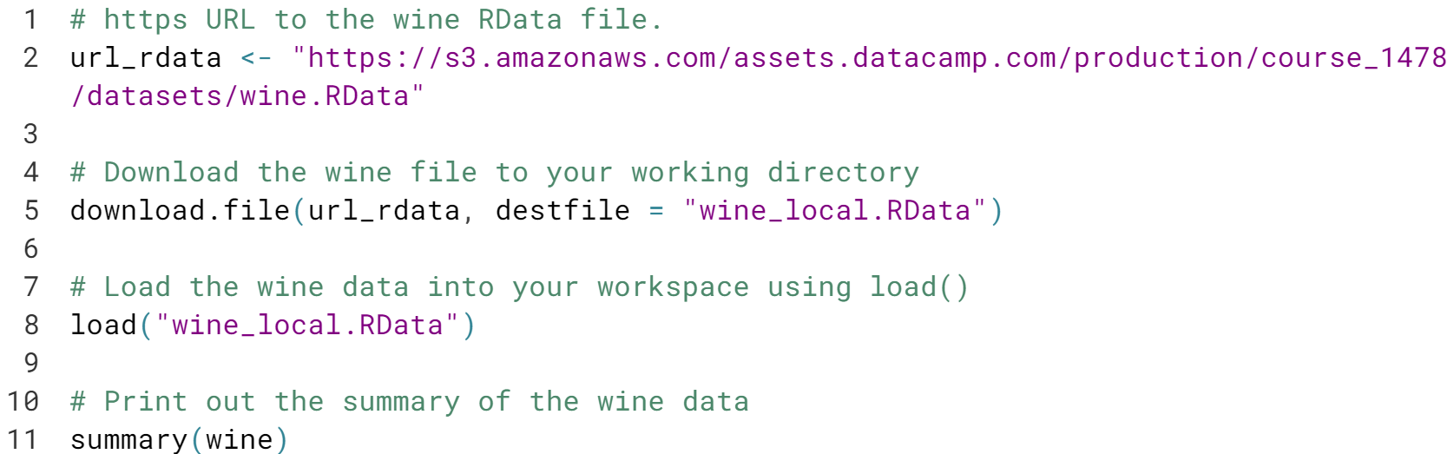

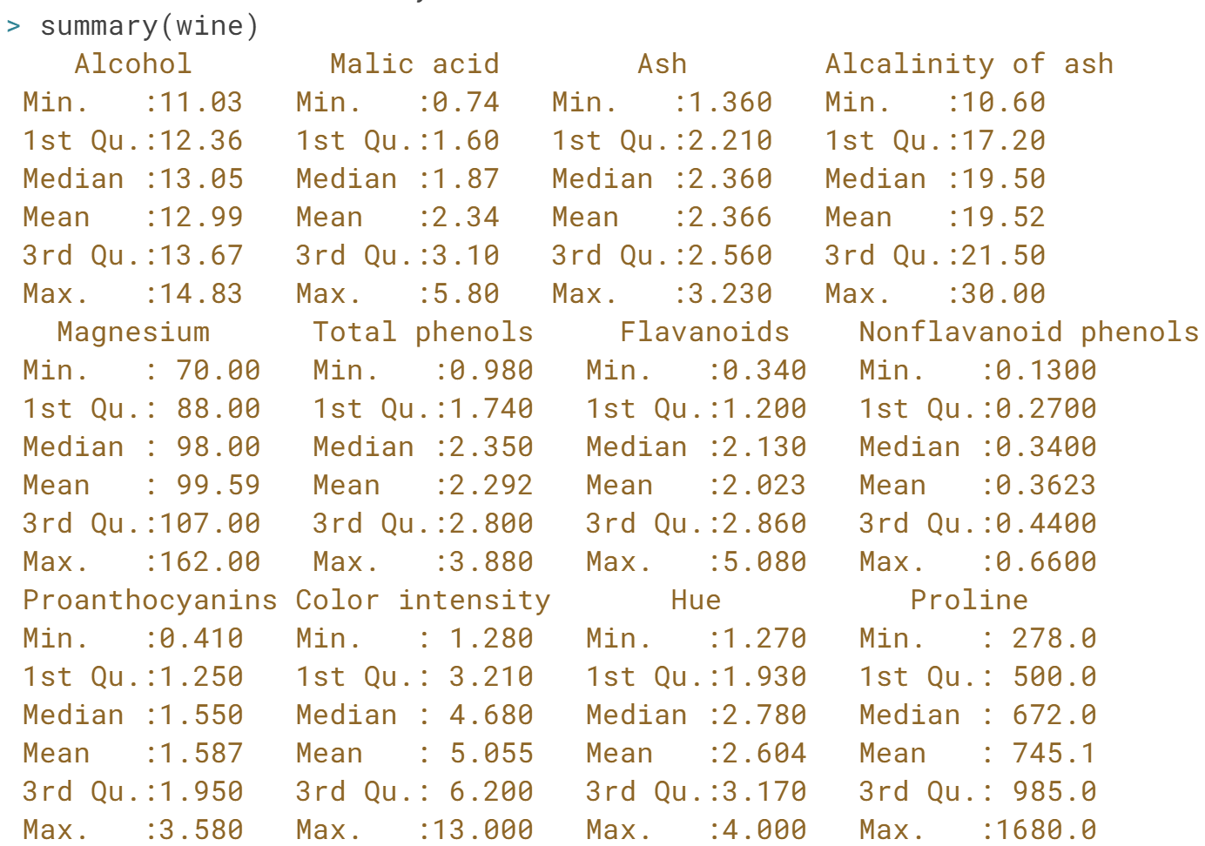

Great! Another way to load remote RData files is to use the ***url()*** function inside ***load()***. However, this will not save the RData file to a local file.

# Reading a text file from the web

Wow, you've learned a lot of ways to import a data file from the web in the previous exercises. Let's see if you can remember what's possible and what's not.

Which way of importing data is NOT possible?

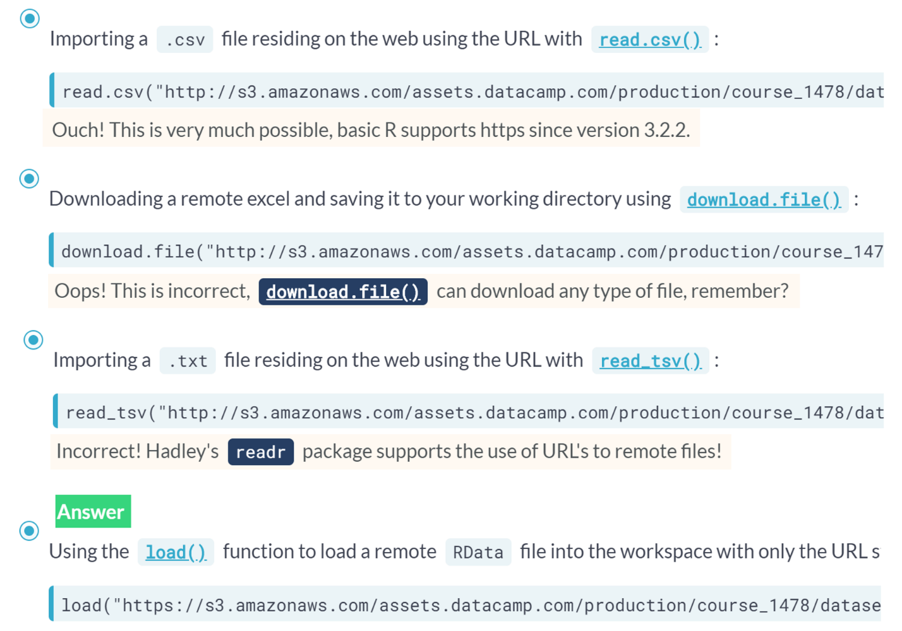Truth! You can't directly use a URL string inside ***load()*** to load remote RData files. You should use ***url()*** or download the file first using ***download.file()***.

# HTTP? httr! (1)

Downloading a file from the Internet means sending a GET request and receiving the file you asked for. Internally, all the previously discussed functions use a GET request to download files.

httr provides a convenient function, [**GET()**](http://www.rdocumentation.org/packages/httr/functions/GET) to execute this GET request. The result is a response object, that provides easy access to the status code, content-type and, of course, the actual content.

You can extract the content from the request using the [**content()**](http://www.rdocumentation.org/packages/httr/functions/content) function. At the time of writing, there are three ways to retrieve this content: as a raw object, as a character vector, or an R object, such as a list. If you don't tell [**content()**](http://www.rdocumentation.org/packages/httr/functions/content) how to retrieve the content through the as argument, it'll try its best to figure out which type is most appropriate based on the content-type.

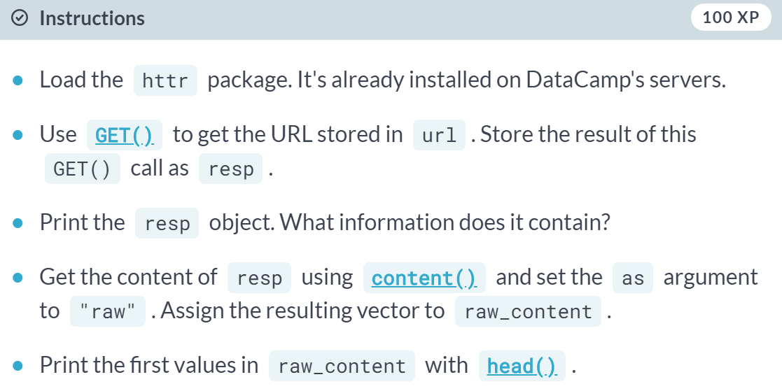

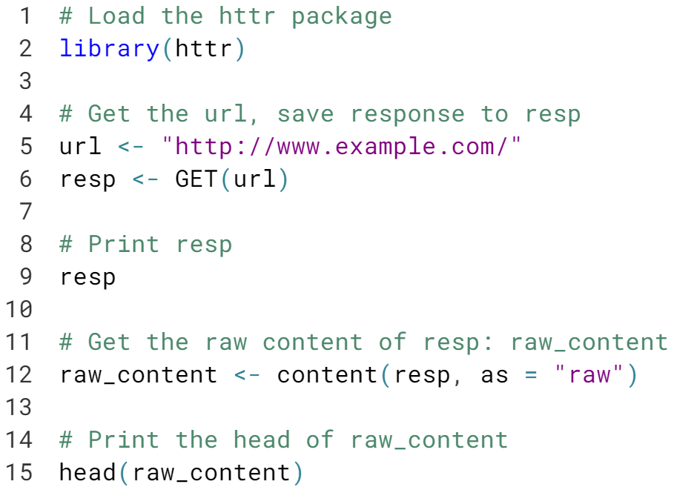

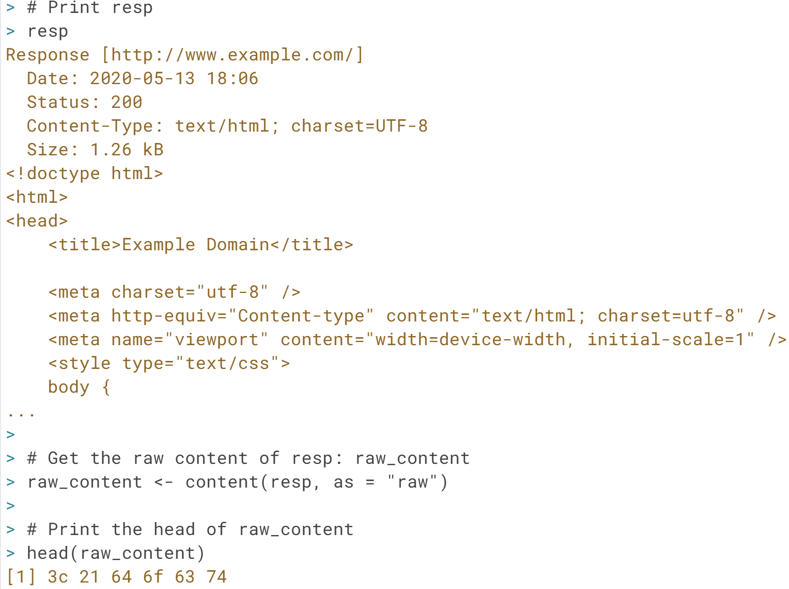

Great! The raw content of the response doesn't make a lot of sense, does it? Luckily, the ***content()*** function by default, if you don't specify the as argument, automatically figures out what type of data you're dealing with and parses it for you.

# HTTP? httr! (2)

Web content does not limit itself to HTML pages and files stored on remote servers such as DataCamp's Amazon S3 instances. There are many other data formats out there. A very common one is JSON. This format is very often used by so-called Web APIs, interfaces to web servers with which you as a client can communicate to get or store information in more complicated ways.

You'll learn about Web APIs and JSON in the video and exercises that follow, but some experimentation never hurts, does it?

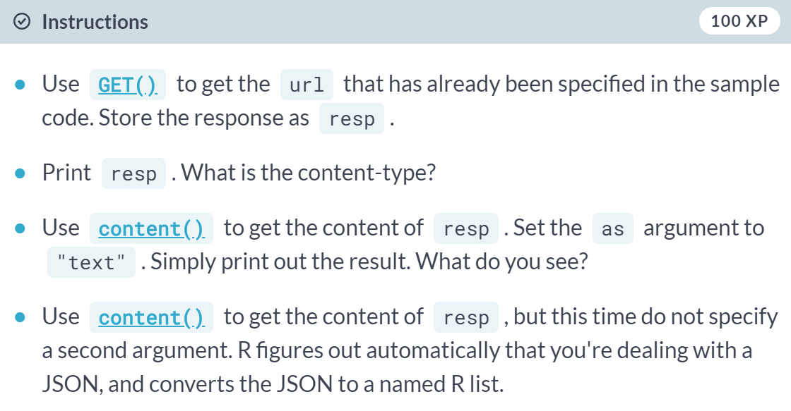

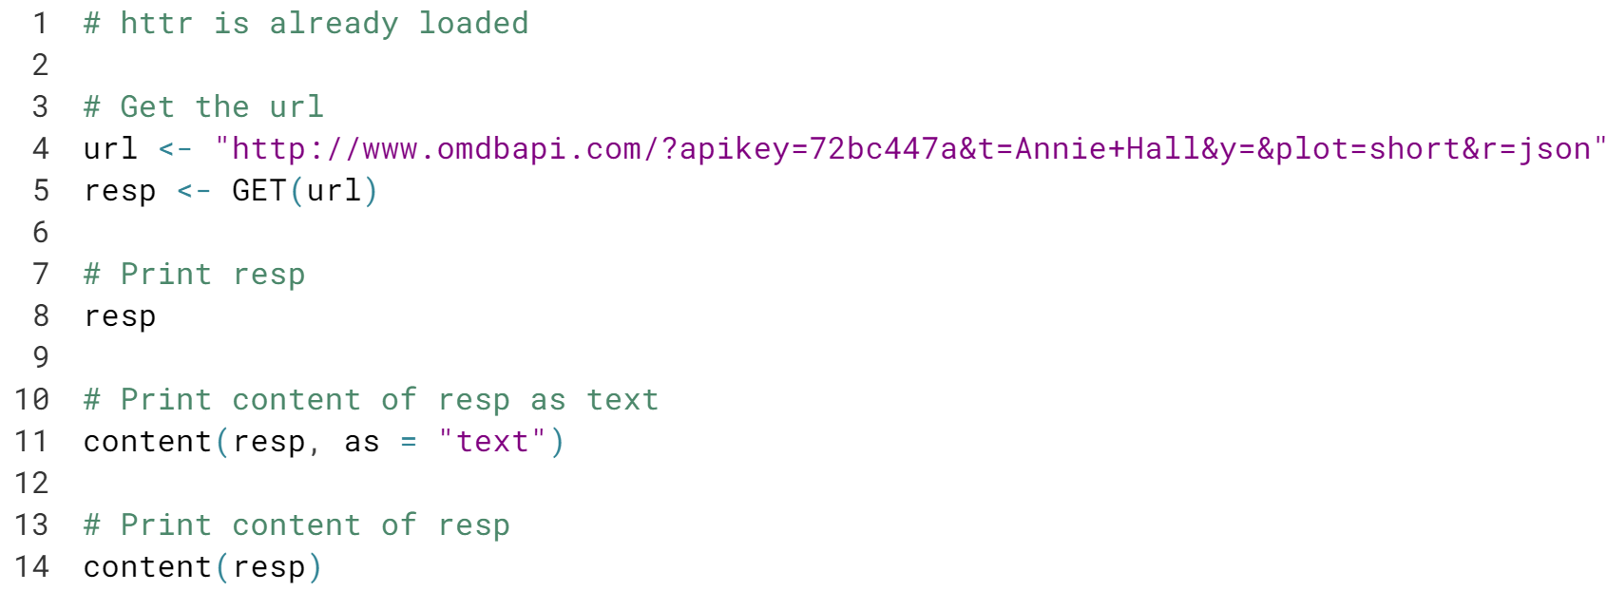

The fact that ***httr*** converts the JSON response body automatically to an R list makes it so convenient to use.

#### **Importing data from the web (Part 2)**

Importing data from the web is one thing; actually, being able to extract useful information is another. Learn more about the JSON format to get one step closer to web domination.

# From JSON to R

In the simplest setting, [**fromJSON()**](http://www.rdocumentation.org/packages/jsonlite/functions/fromJSON) can convert character strings that represent JSON data into a nicely structured R list. Give it a try!

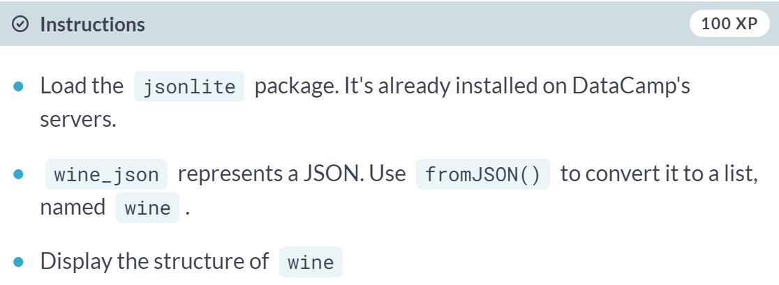

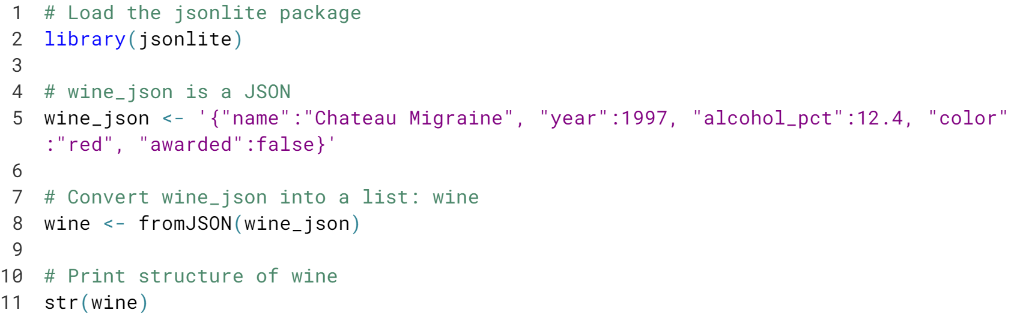

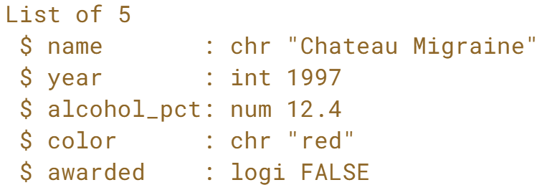

# Quandl API

As described, [**fromJSON()**](http://www.rdocumentation.org/packages/jsonlite/functions/fromJSON) also works if you pass a URL as a character string or the path to a local file that contains JSON data. Let's try this out on the Quandl API, where you can fetch all sorts of financial and economical data.

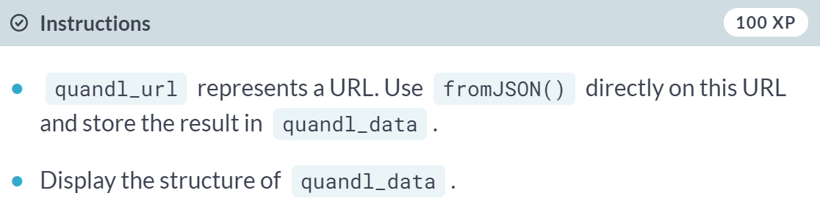

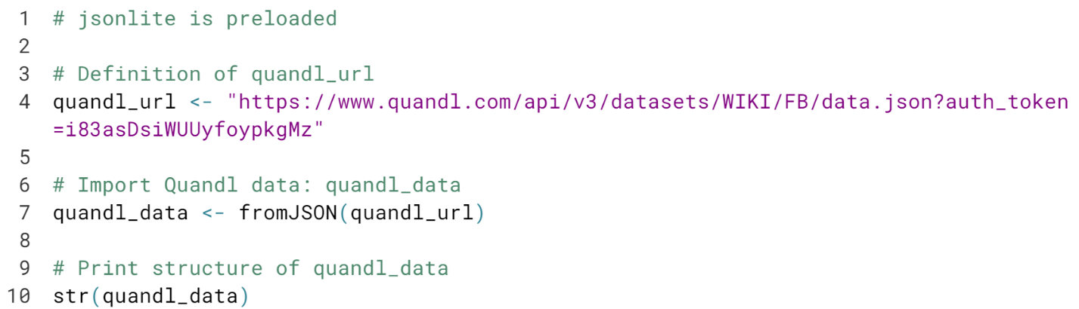

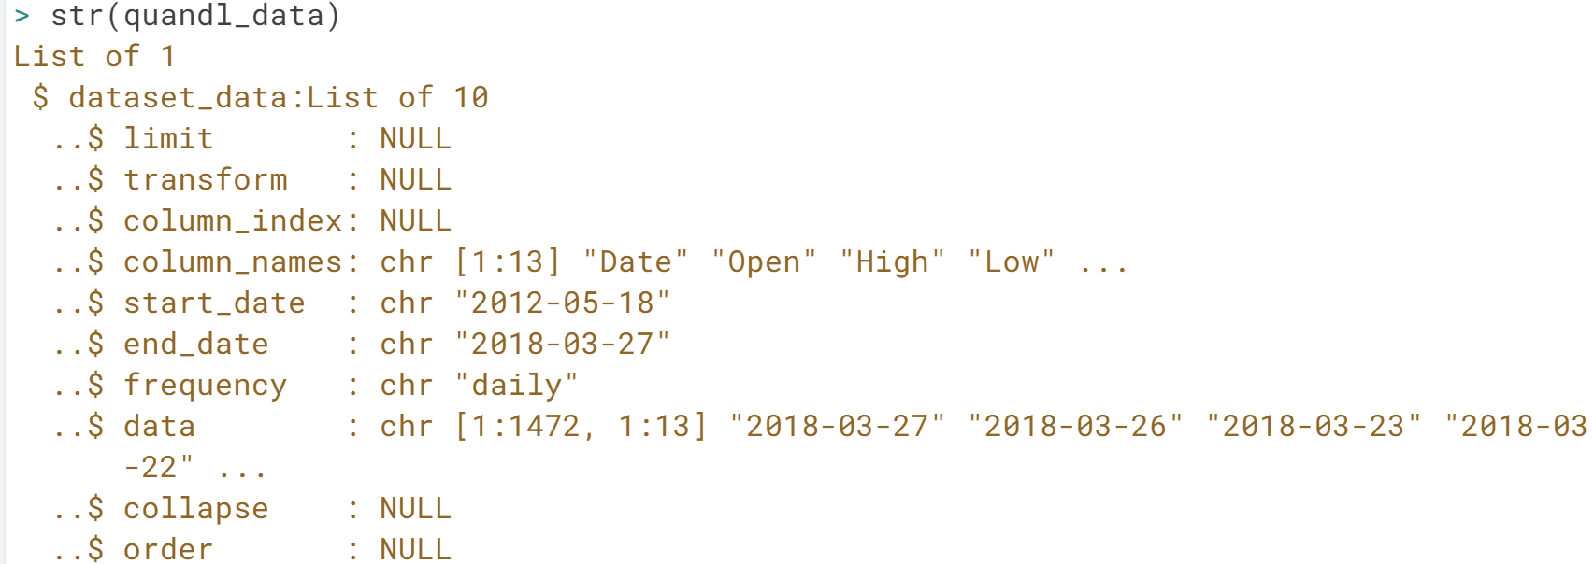

You successfully imported JSON data directly from the web. If you have a close look at the structure of ***quandl\_data***, you will see that the data element is a matrix.

# OMDb API

In the video, you saw how easy it is to interact with an API once you know how to formulate requests. You also saw how to fetch all information on Rain Man from OMDb. Simply perform a [**GET()**](http://www.rdocumentation.org/packages/httr/functions/GET) call, and next ask for the contents with the [**content()**](http://www.rdocumentation.org/packages/httr/functions/content) function. This [**content()**](http://www.rdocumentation.org/packages/httr/functions/content) function, which is part of the httr package, uses jsonlite behind the scenes to import the JSON data into R.

However, by now you also know that jsonlite can handle URLs itself. Simply passing the request URL to [**fromJSON()**](http://www.rdocumentation.org/packages/jsonlite/functions/fromJSON) will get your data into R. In this exercise, you will be using this technique to compare the release year of two movies in the Open Movie Database.

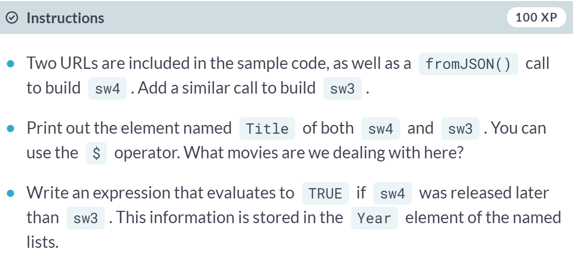

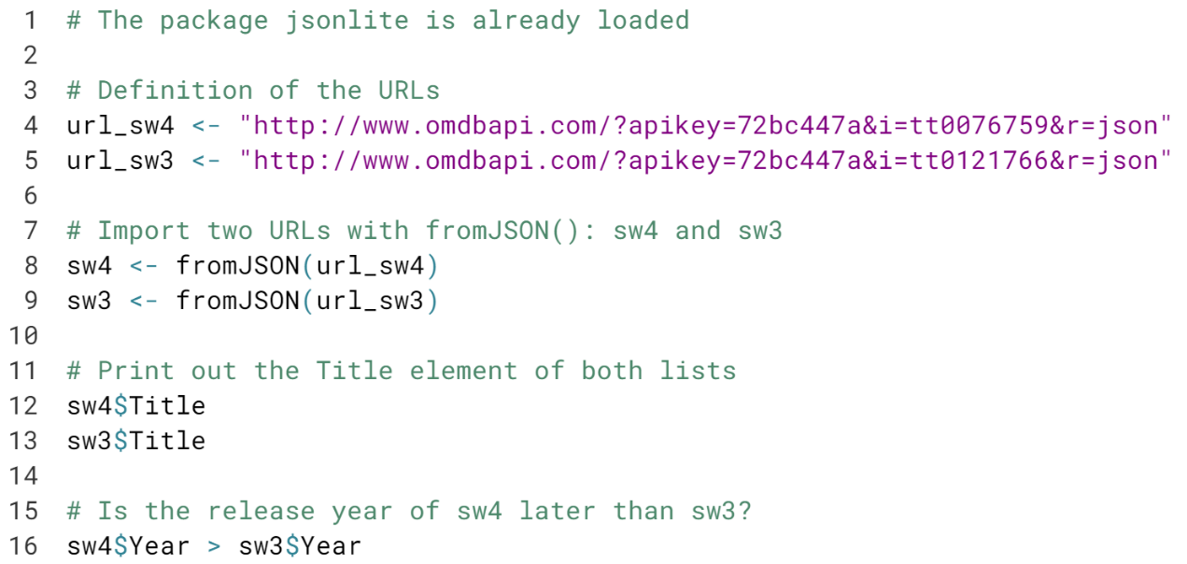

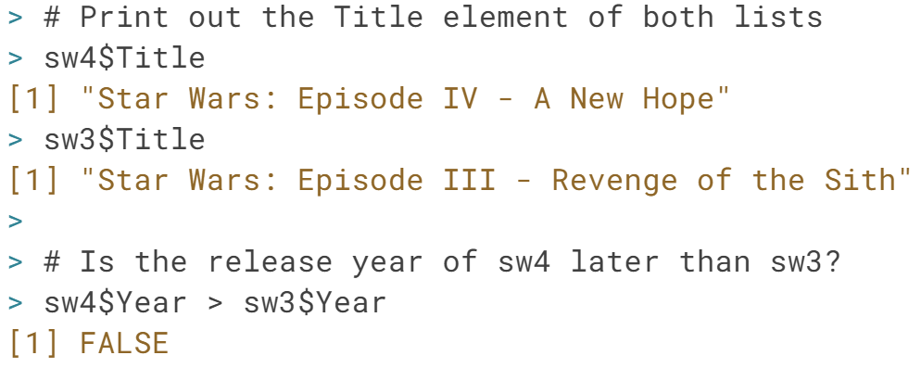

# JSON practice (1)

JSON is built on two structures: objects and arrays. To help you experiment with these, two JSON strings are included in the sample code. It's up to you to change them appropriately and then call jsonlite's [**fromJSON()**](http://www.rdocumentation.org/packages/jsonlite/functions/fromJSON) function on them each time.

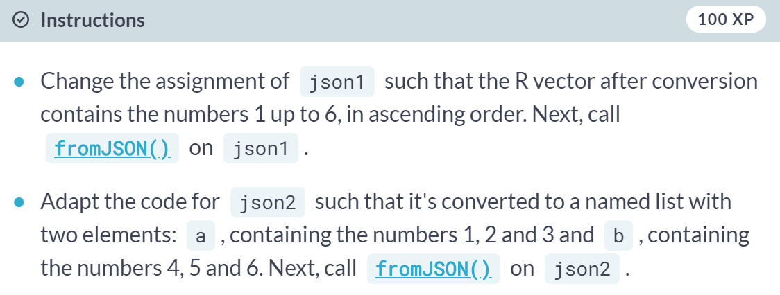

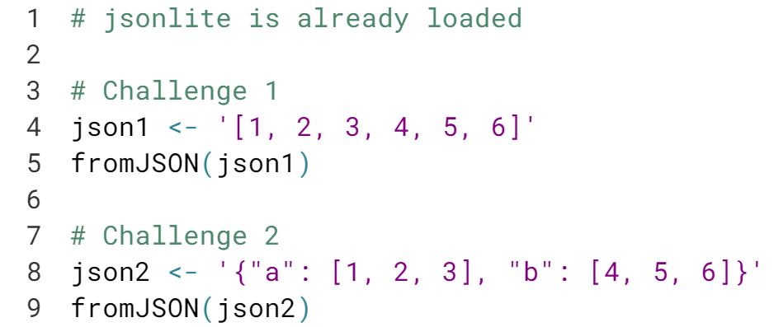

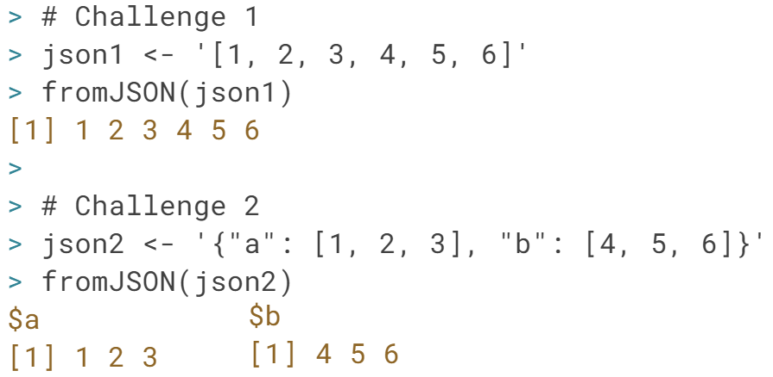

# JSON practice (2)

We prepared two more JSON strings in the sample code. Can you change them and call jsonlite's [**fromJSON()**](http://www.rdocumentation.org/packages/jsonlite/functions/fromJSON) function on them, similar to the previous exercise?

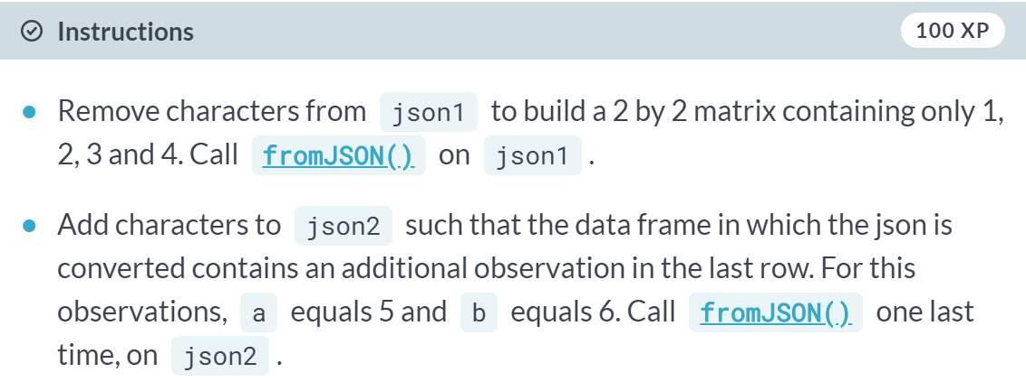

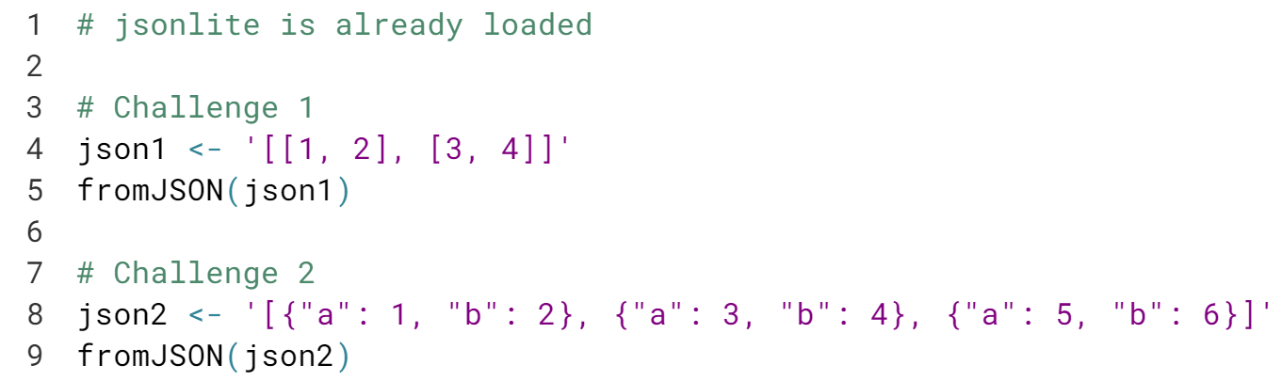

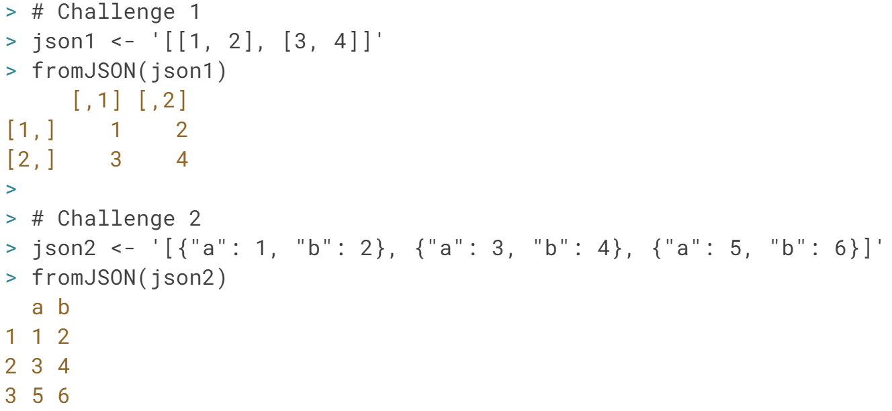Great! As you can see different JSON data structures will lead to different data structures in R.

# toJSON()

Apart from converting JSON to R with [**fromJSON()**](http://www.rdocumentation.org/packages/jsonlite/functions/fromJSON), you can also use [**toJSON()**](http://www.rdocumentation.org/packages/jsonlite/functions/fromJSON) to convert R data to a JSON format. In its most basic use, you simply pass this function an R object to convert to a JSON. The result is an R object of the class json, which is basically a character string representing that JSON.

For this exercise, you will be working with a .csv file containing information on the amount of desalinated water that is produced around the world. As you'll see, it contains a lot of missing values. This data can be found on the URL that is specified in the sample code.

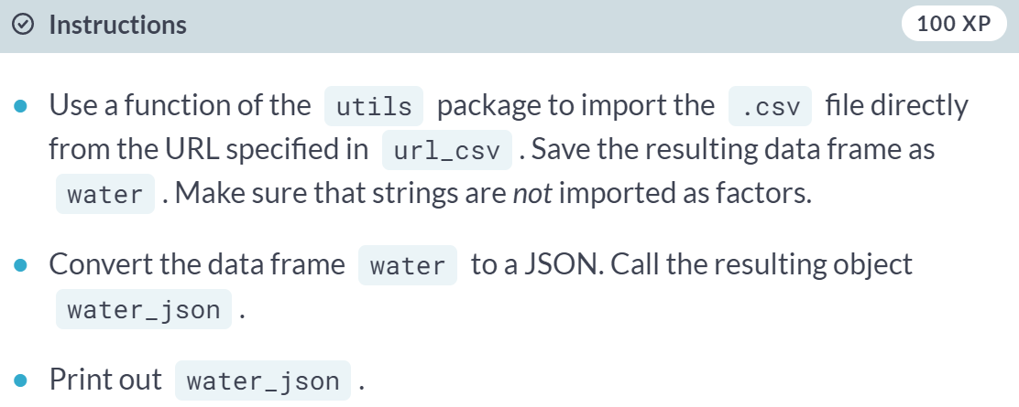

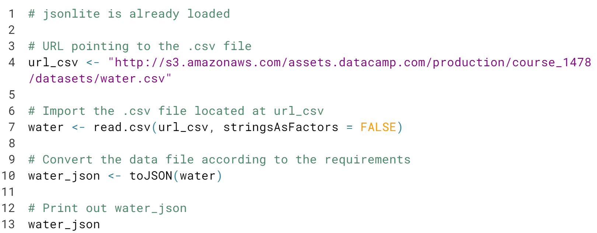

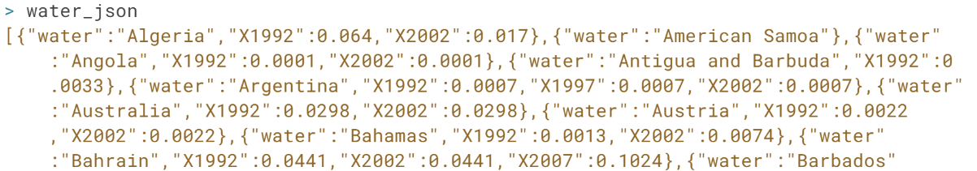  
As you can see, the JSON you printed out is not easy to read. In the next exercise, you will print out some more JSONs, and explore ways to prettify or minify the output.

# Minify and prettify

JSONs can come in different formats. Take these two JSONs, that are in fact exactly the same: the first one is in a minified format, the second one is in a pretty format with indentation, whitespace and new lines:

# Mini

{"a":1,"b":2,"c":{"x":5,"y":6}}

# Pretty

{

"a": 1,

"b": 2,

"c": {

"x": 5,

"y": 6

}

}

Unless you're a computer, you surely prefer the second version. However, the standard form that [**toJSON()**](http://www.rdocumentation.org/packages/jsonlite/functions/fromJSON) returns, is the minified version, as it is more concise. You can adapt this behavior by setting the pretty argument inside [**toJSON()**](http://www.rdocumentation.org/packages/jsonlite/functions/fromJSON) to TRUE. If you already have a JSON string, you can use [**prettify()**](http://www.rdocumentation.org/packages/jsonlite/functions/prettify) or [**minify()**](http://www.rdocumentation.org/packages/jsonlite/functions/prettify) to make the JSON pretty or as concise as possible.

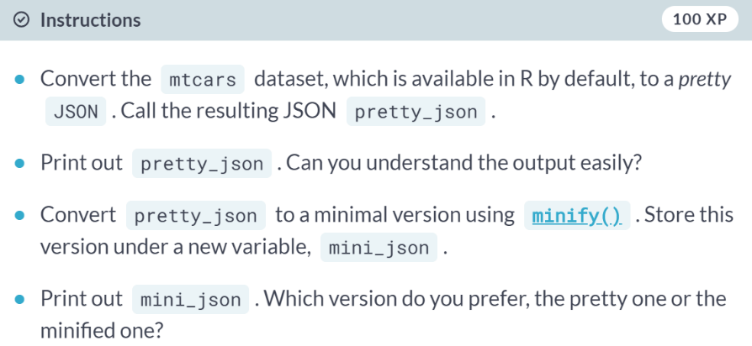

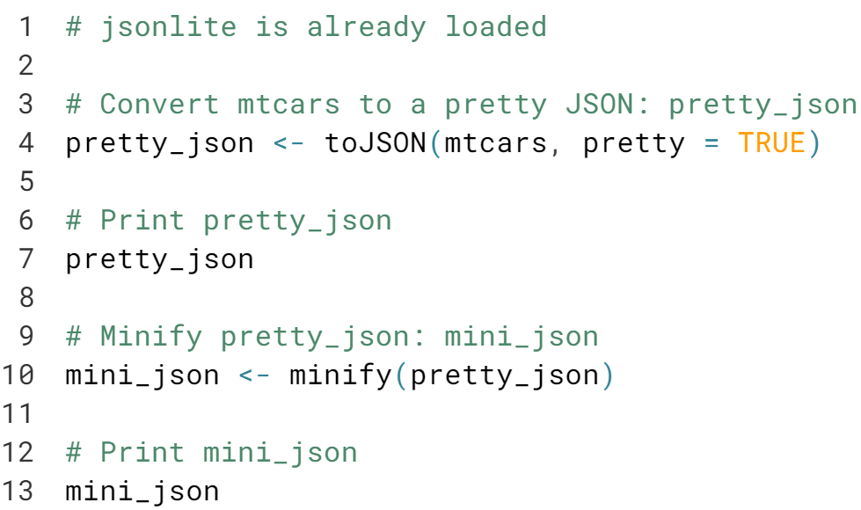

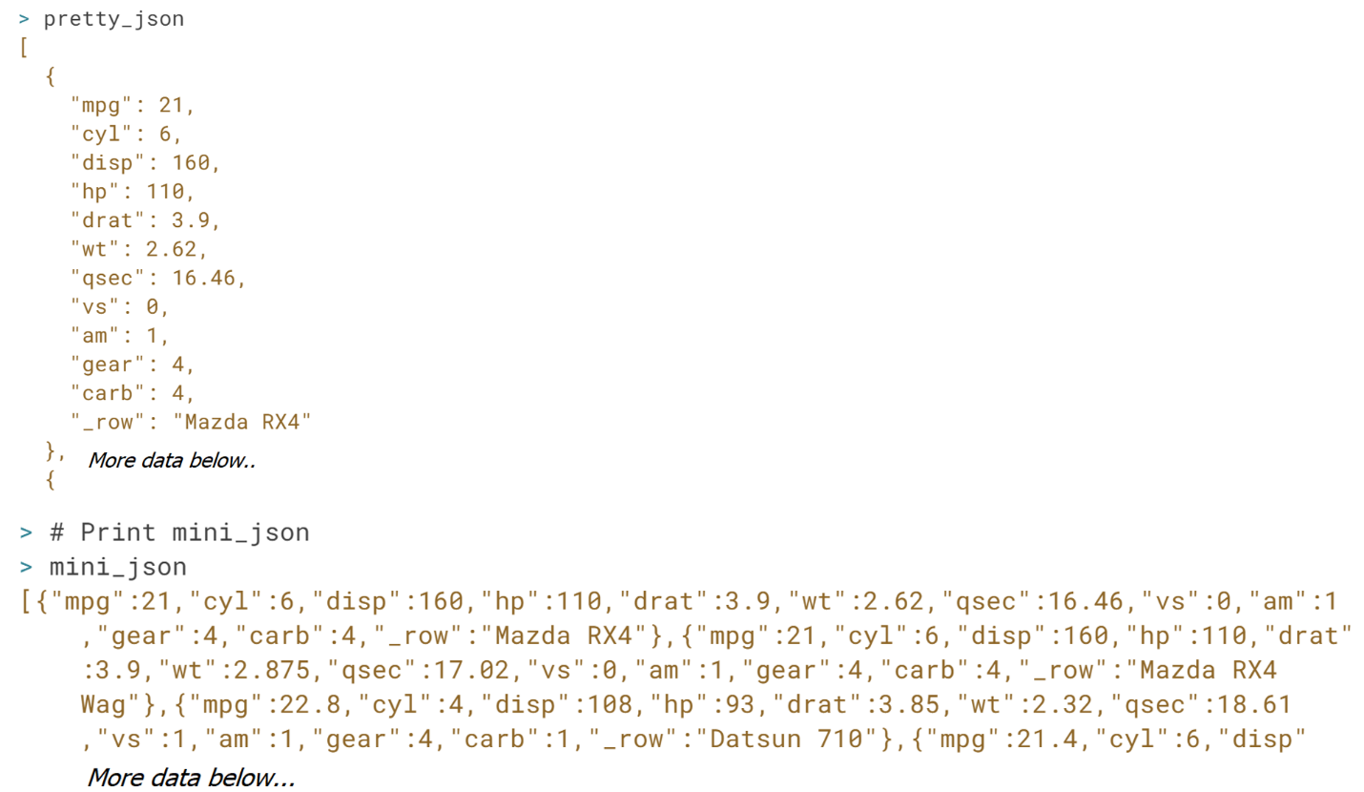

Great. Hopefully, you agree that the pretty format is way easier to read and understand than the minified format.

#### **Importing data from statistical software packages**

#### Next to R, there are also other commonly used statistical software packages: SAS, STATA and SPSS. Each of them has their own file format. Learn how to use the haven and foreign packages to get them into R with remarkable ease!

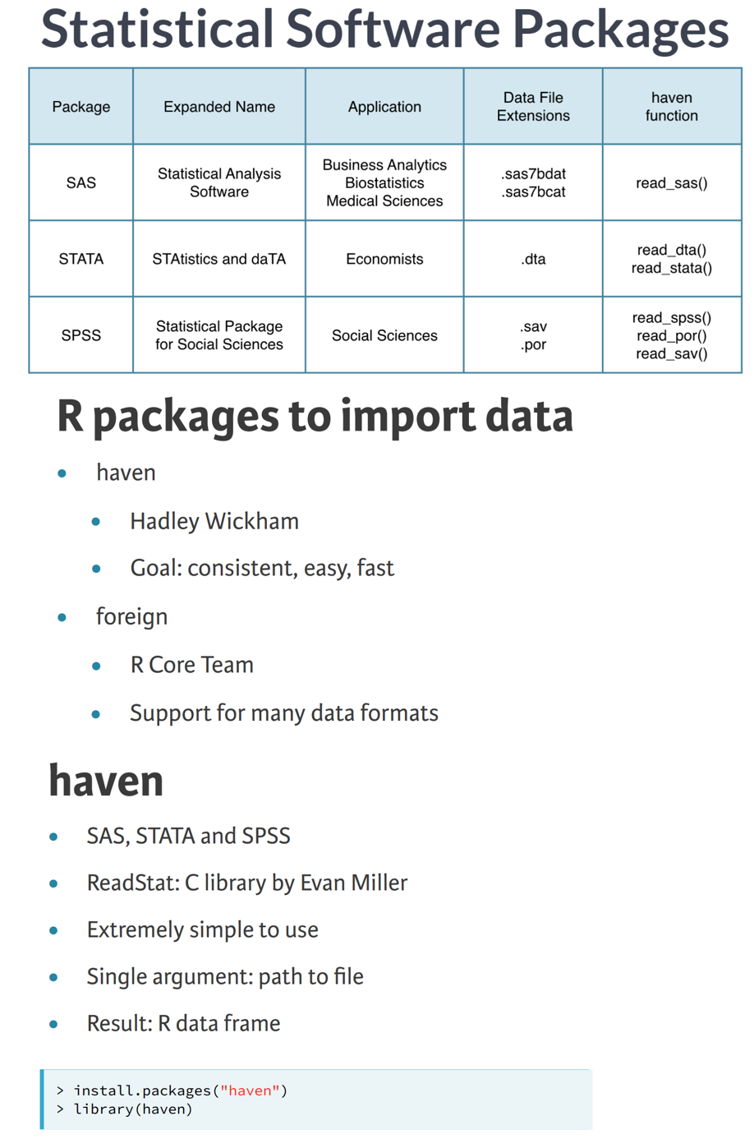

# Import SAS data with haven

haven is an extremely easy-to-use package to import data from three software packages: SAS, STATA and SPSS. Depending on the software, you use different functions:

* SAS: **[read\_sas()](http://cran.r-project.org/web/packages/haven/haven.pdf" \t "_blank)**
* STATA: **[read\_dta()](http://cran.r-project.org/web/packages/haven/haven.pdf" \t "_blank)** (or **[read\_stata()](http://cran.r-project.org/web/packages/haven/haven.pdf" \t "_blank)**, which are identical)
* SPSS: **[read\_sav()](http://cran.r-project.org/web/packages/haven/haven.pdf" \t "_blank)** or **[read\_por()](http://cran.r-project.org/web/packages/haven/haven.pdf" \t "_blank)**, depending on the file type.

All these functions take one key argument: the path to your local file. In fact, you can even pass a URL; haven will then automatically download the file for you before importing it. You'll be working with data on the age, gender, income, and purchase level (0 = low, 1 = high) of 36 individuals (Source: [**SAS**](http://support.sas.com/learn/)). The information is stored in a SAS file, sales.sas7bdat, which is available in your current working directory. You can also download the data [**here**](http://s3.amazonaws.com/assets.datacamp.com/production/course_1478/datasets/sales.sas7bdat).

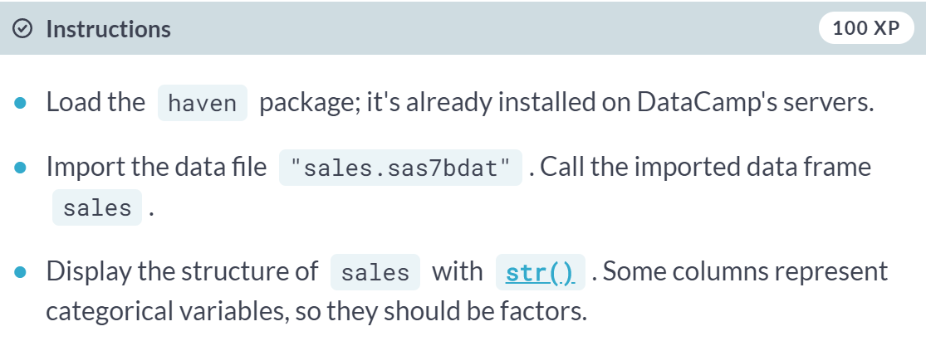  
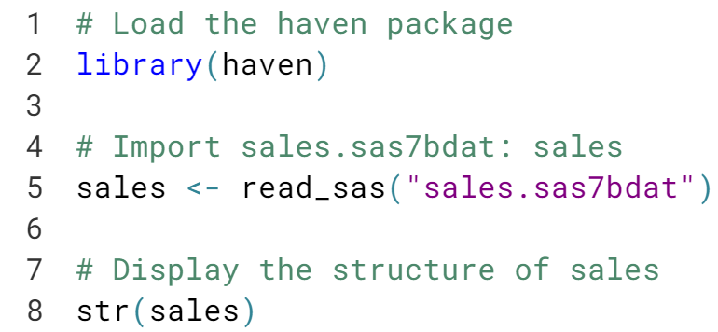  
  
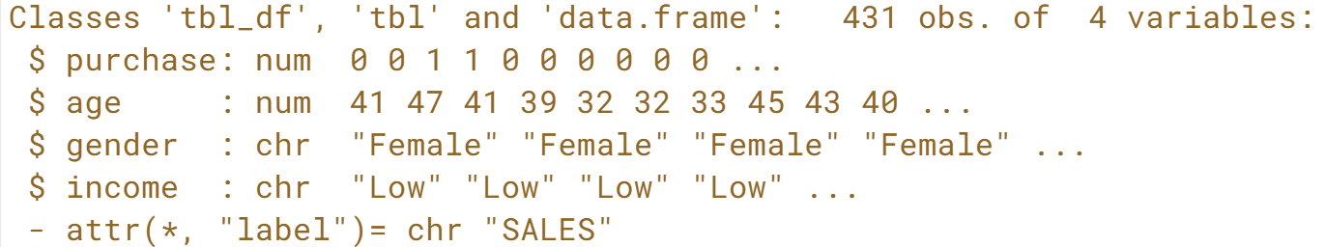  
As you can see, **read\_sas()** enables you to import SAS data files easily.

# Import STATA data with haven

Next up are STATA data files; you can use **[read\_dta()](http://cran.r-project.org/web/packages/haven/haven.pdf" \t "_blank)** for these.

When inspecting the result of the read\_dta() call, you will notice that one column will be imported as a labelled vector, an R equivalent for the common data structure in other statistical environments. In order to effectively continue working on the data in R, it's best to change this data into a standard R class. To convert a variable of the class labelled to a factor, you'll need haven's [**as\_factor()**](http://cran.r-project.org/web/packages/haven/haven.pdf) function.

In this exercise, you will work with data on yearly import and export numbers of sugar, both in USD and in weight. The data can be found at: [**http://assets.datacamp.com/production/course\_1478/datasets/trade.dta**](http://assets.datacamp.com/production/course_1478/datasets/trade.dta)

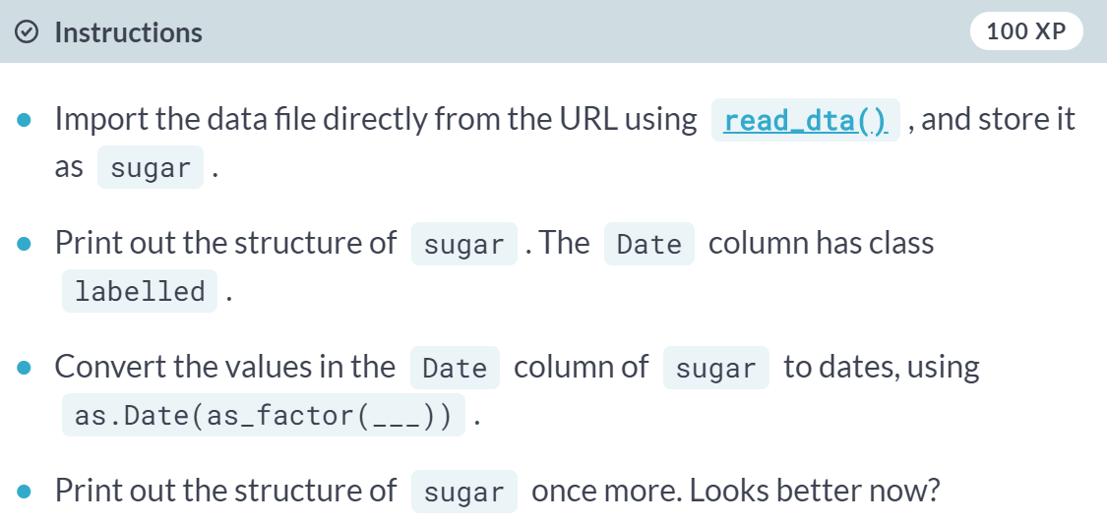

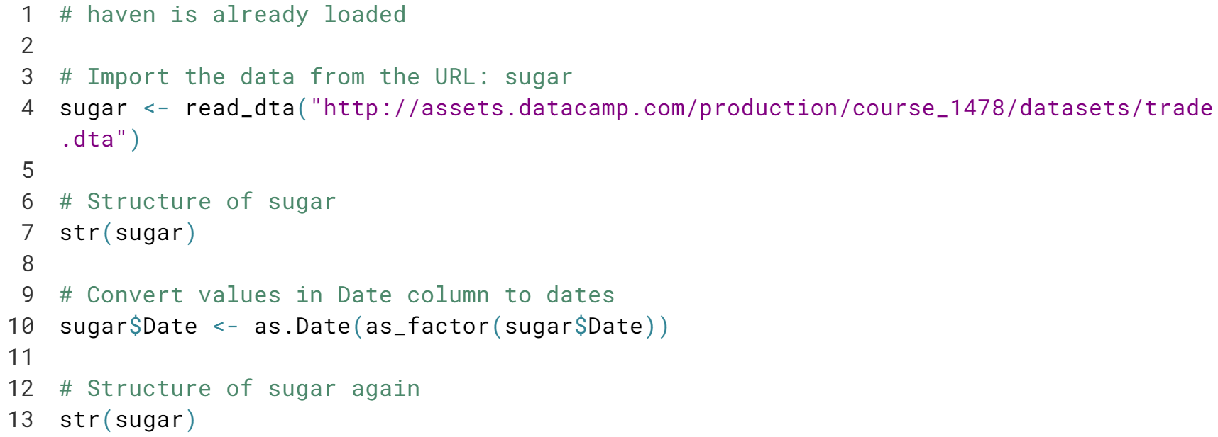

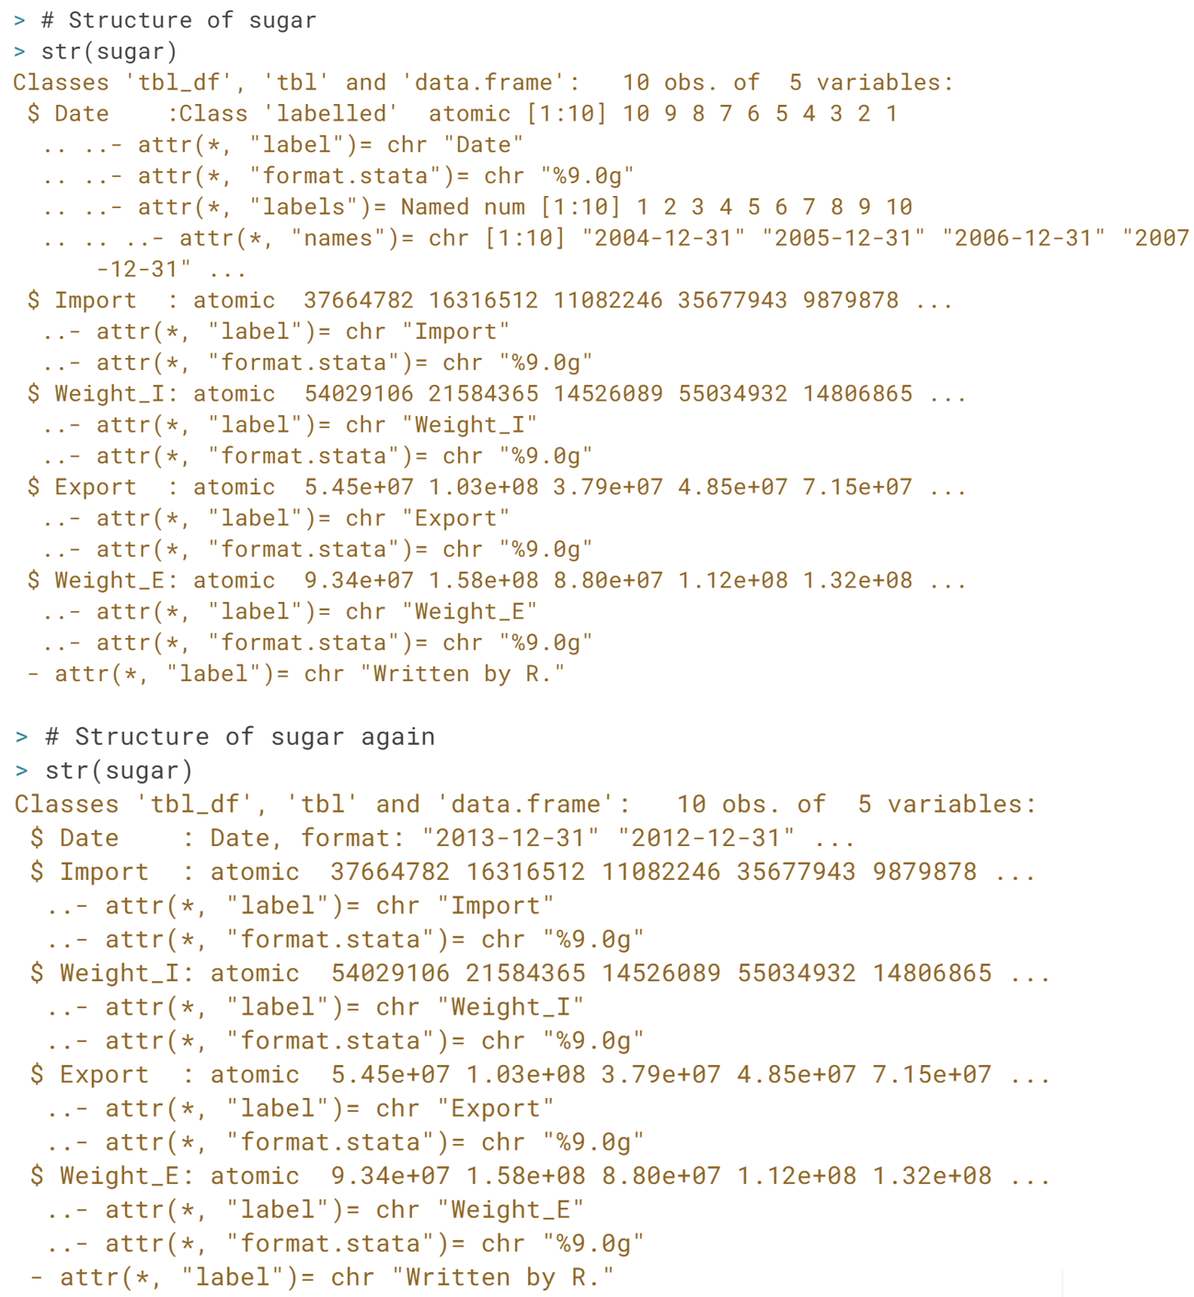

# What does the graphic tell?

A plot can be very useful to explore the relationship between two variables. If you pass the [**plot()**](http://www.rdocumentation.org/packages/graphics/functions/plot) function two arguments, the first one will be plotted on the x-axis, the second one will be plotted on the y-axis.

The sugar trading data is again available at [**http://assets.datacamp.com/production/course\_1478/datasets/trade.dta**](http://assets.datacamp.com/production/course_1478/datasets/trade.dta).

After you've imported the data frame, you should plot two of its variables, Import against Weight\_I, and describe their relationship! haven is already loaded in your R session, so you can start importing straight away.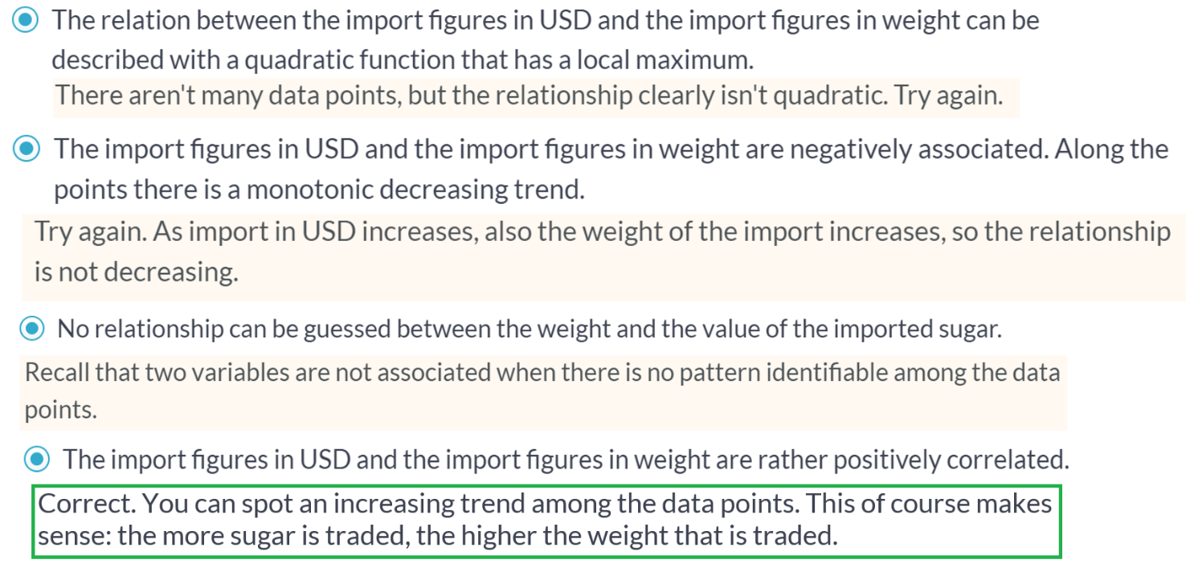  
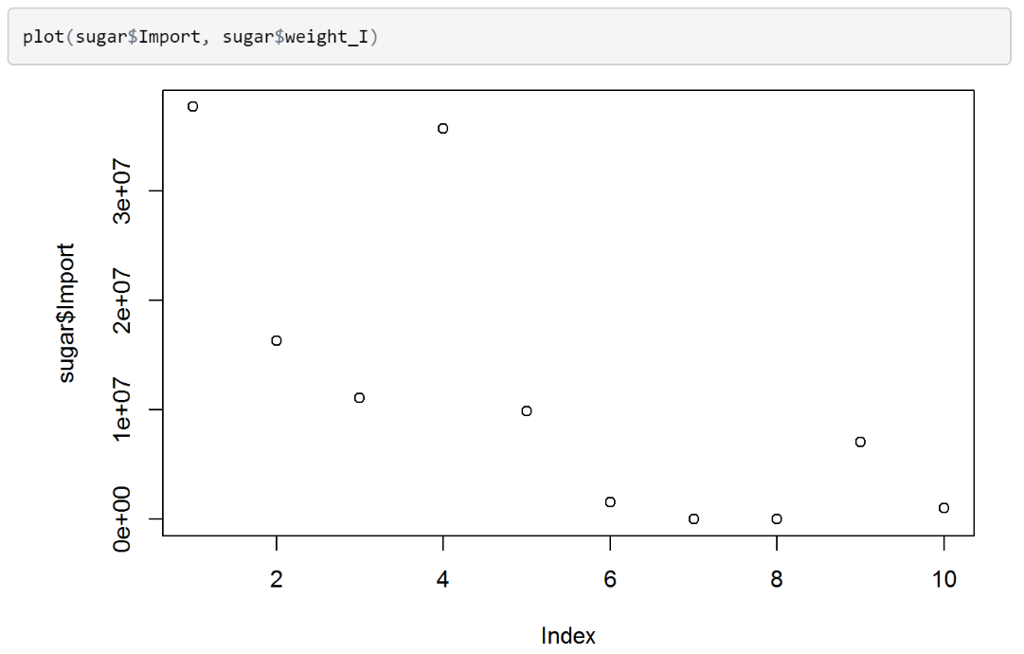

# Import SPSS data with haven

The haven package can also import data files from SPSS. Again, importing the data is pretty straightforward. Depending on the SPSS data file you're working with, you'll need either **[read\_sav()](http://cran.r-project.org/web/packages/haven/haven.pdf" \t "_blank)** - for .sav files - or **[read\_por()](http://cran.r-project.org/web/packages/haven/haven.pdf" \t "_blank)** - for .por files.

In this exercise, you will work with data on four of the Big Five personality traits for 434 persons (Source: [**University of Bath**](http://staff.bath.ac.uk/pssiw/stats2/page16/page16.html)). The Big Five is a psychological concept including, originally, five dimensions of personality to classify human personality. The SPSS dataset is called **[person.sav](http://s3.amazonaws.com/assets.datacamp.com/production/course_1478/datasets/person.sav" \t "_blank)** and is available in your working directory.

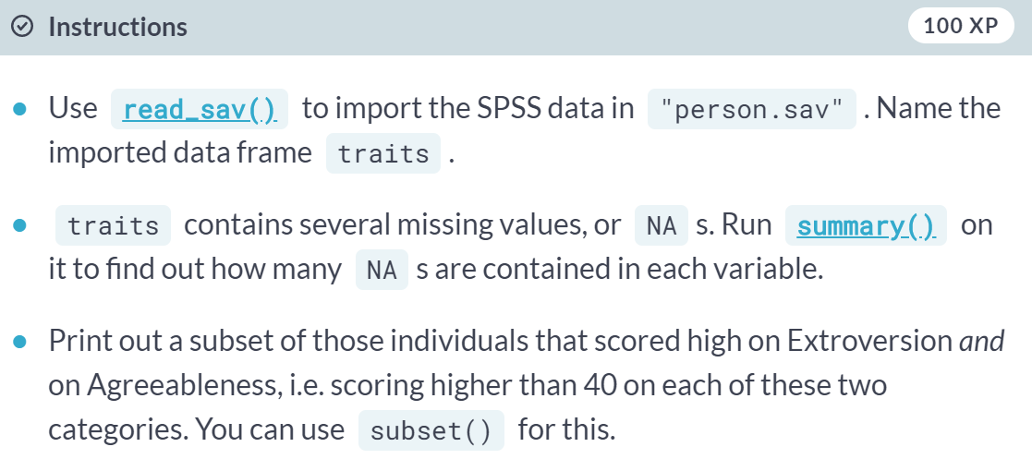

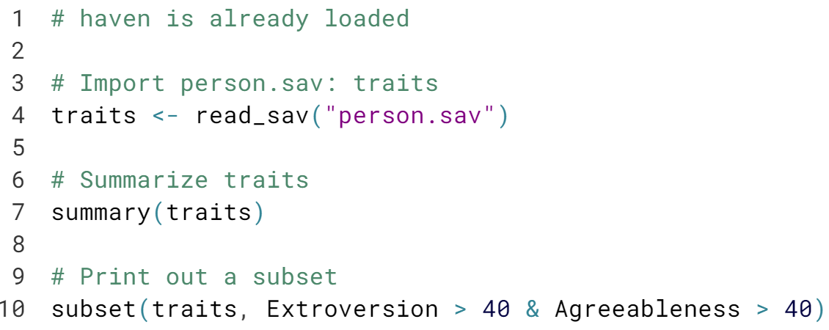

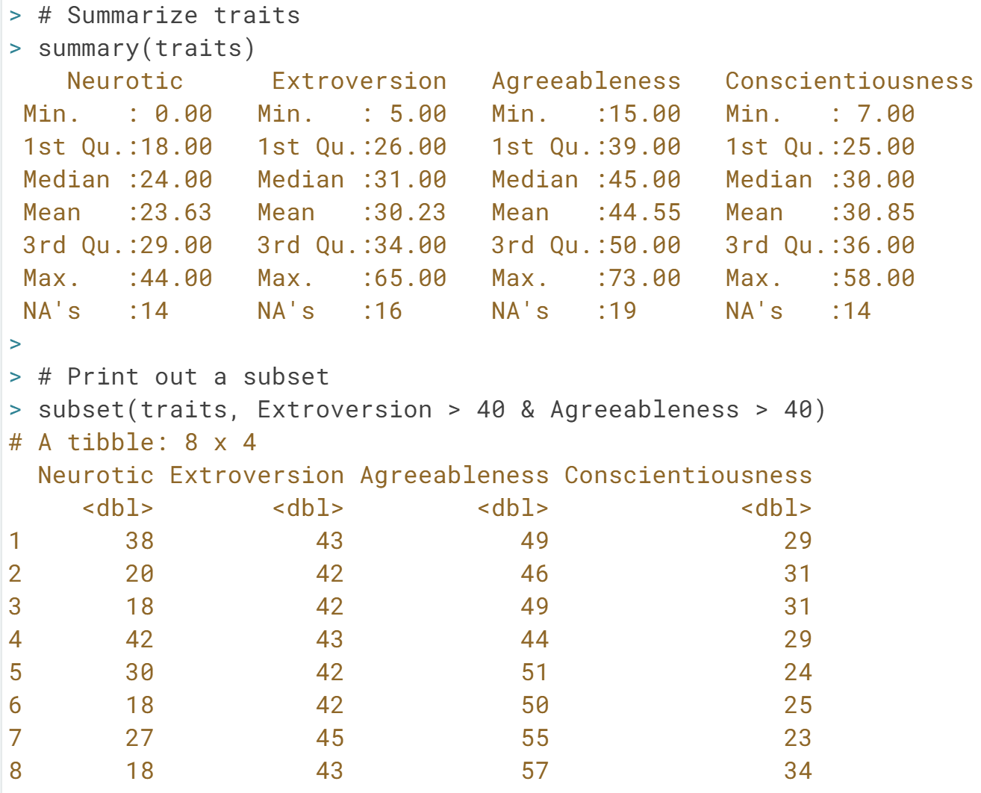

Great! You imported a data file from SPSS correctly using ***read\_sav()***. Deepen your knowledge in the following exercise!

# Factorize, round two

In the last exercise you learned how to import a data file using the command **[read\_sav()](http://cran.r-project.org/web/packages/haven/haven.pdf" \t "_blank)**. With SPSS data files, it can also happen that some of the variables you import have the labelled class. This is done to keep all the labelling information that was originally present in the .sav and .por files. It's advised to coerce (or change) these variables to factors or other standard R classes.

The data for this exercise involves information on employees and their demographic and economic attributes (Source: **[QRiE](http://cehd.gmu.edu/book/dimitrov/spss" \t "_blank)**). The data can be found on the following URL:

[**http://s3.amazonaws.com/assets.datacamp.com/production/course\_1478/datasets/employee.sav**](http://s3.amazonaws.com/assets.datacamp.com/production/course_1478/datasets/employee.sav)

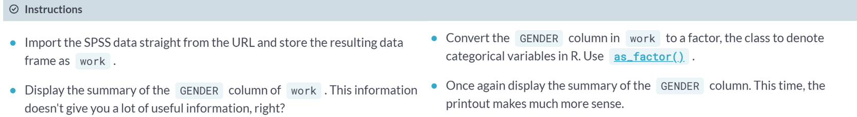  
  
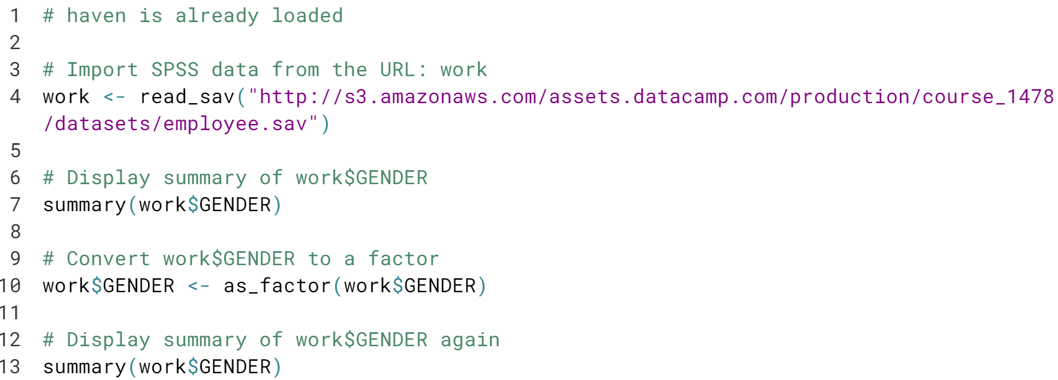

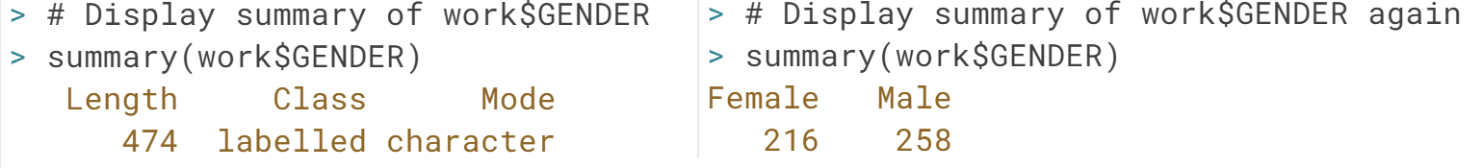

Well done! The ***as\_factor()***  function has more arguments you can specify, have a look at its documentation to discover more! Proceed to the next exercise.

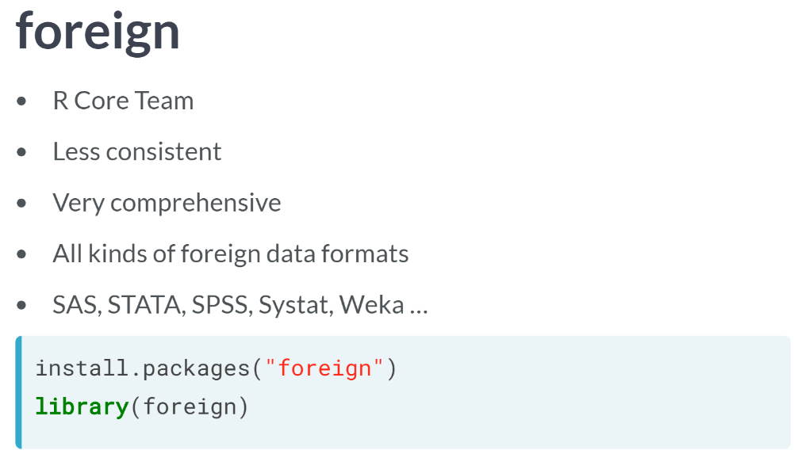

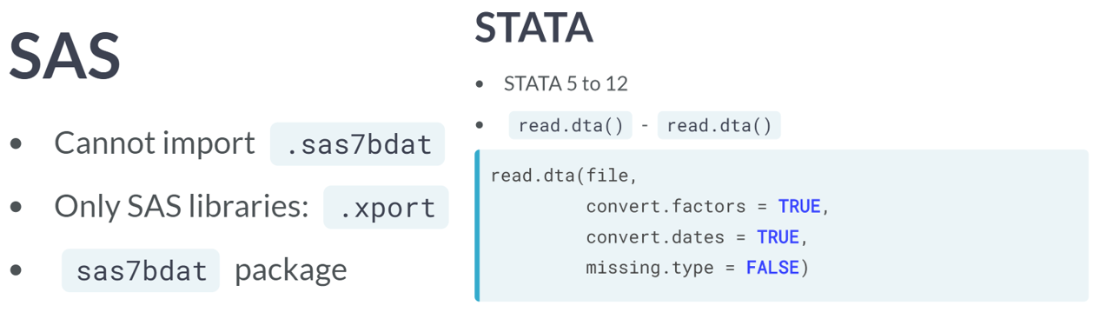

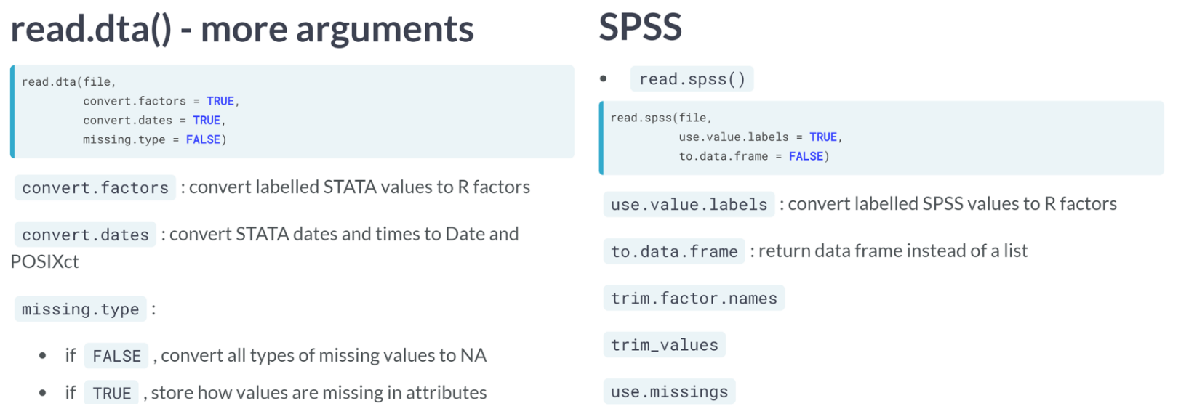

# Import STATA data with foreign (1)

The foreign package offers a simple function to import and read STATA data: [**read.dta()**](http://www.rdocumentation.org/packages/foreign/functions/read.dta).

In this exercise, you will import data on the US presidential elections in the year 2000. The data in florida.dta contains the total numbers of votes for each of the four candidates as well as the total number of votes per election area in the state of Florida (Source: [**Florida Department of State**](http://results.elections.myflorida.com/)). The file is available in your working directory, you can download it [**here**](http://s3.amazonaws.com/assets.datacamp.com/production/course_1478/datasets/florida.dta) if you want to experiment some more.

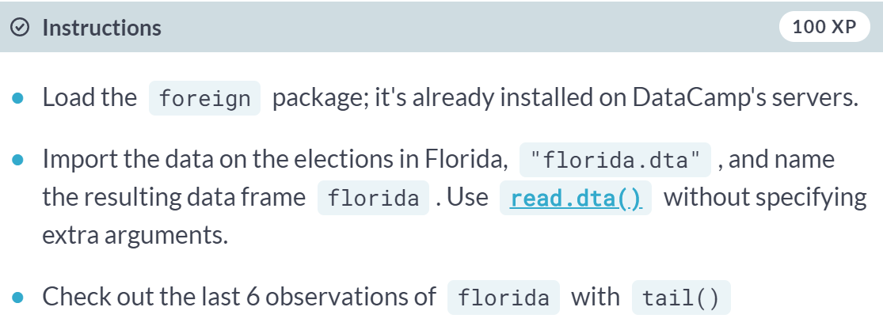

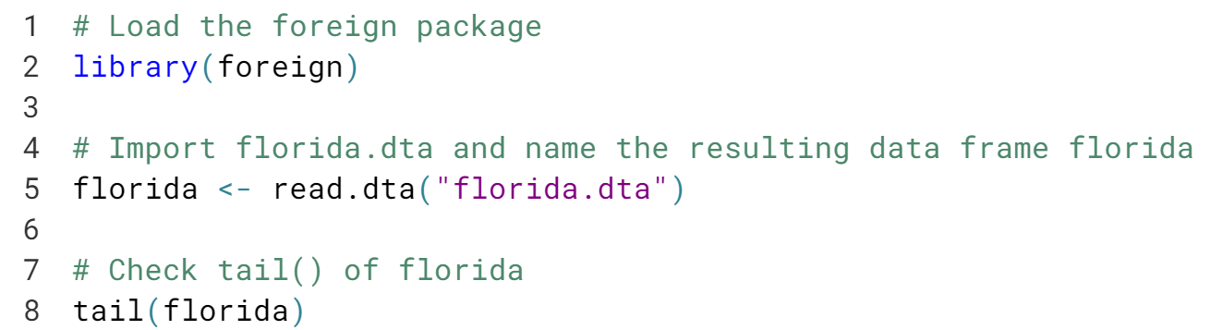

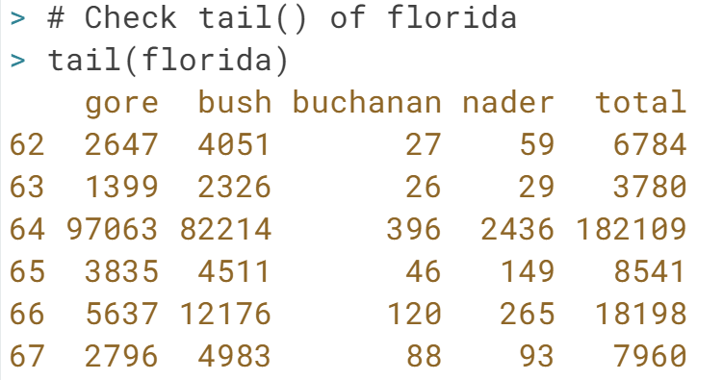  
Congratulations! Your first exercise on using foreign to import STATA data is complete.

# Import STATA data with foreign (2)

Data can be very diverse, going from character vectors to categorical variables, dates and more. It's in these cases that the additional arguments of [**read.dta()**](http://www.rdocumentation.org/packages/foreign/functions/read.dta) will come in handy.

The arguments you will use most often are convert.dates, convert.factors, missing.type and convert.underscore. Their meaning is pretty straightforward, as Filip explained in the video. It's all about correctly converting STATA data to standard R data structures. Type: ?read.dta to find out about about the default values.

The dataset for this exercise contains socio-economic measures and access to education for different individuals (Source: [**World Bank**](http://datatopics.worldbank.org/Gender/topic/education)). This data is available as **[edequality.dta](http://s3.amazonaws.com/assets.datacamp.com/production/course_1478/datasets/edequality.dta" \t "_blank)**, which is located in the worldbank folder in your working directory.

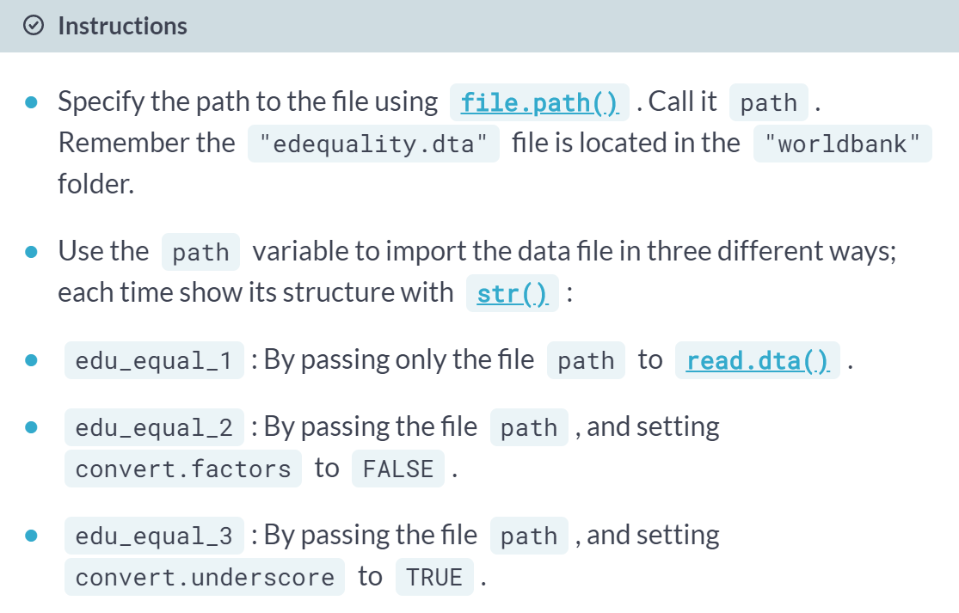

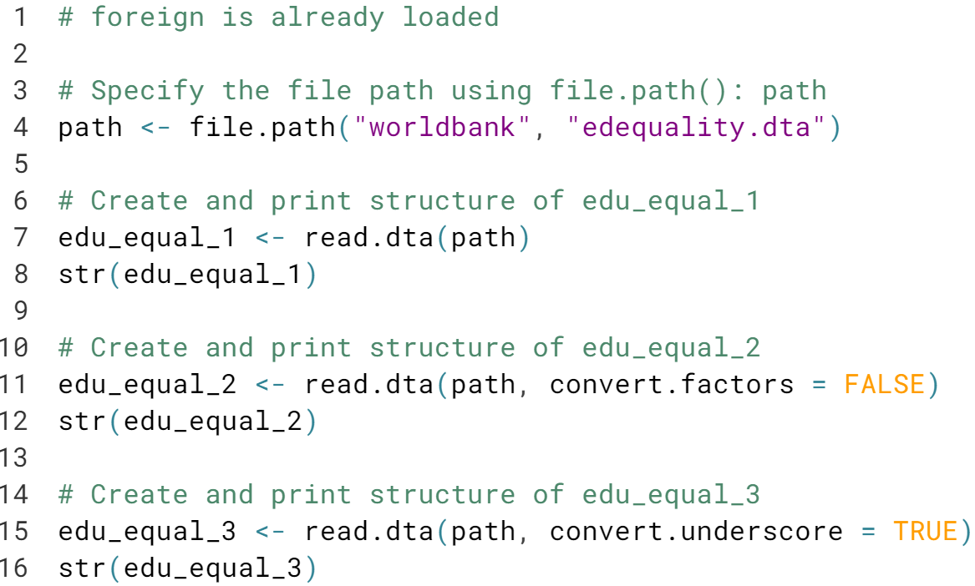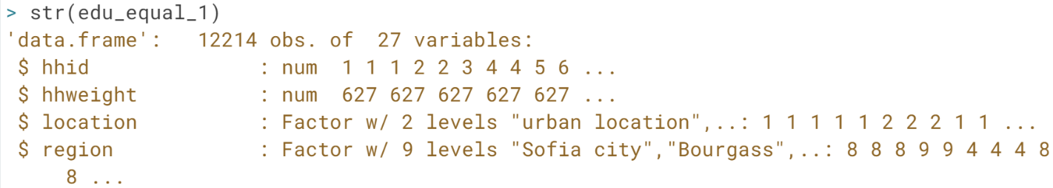

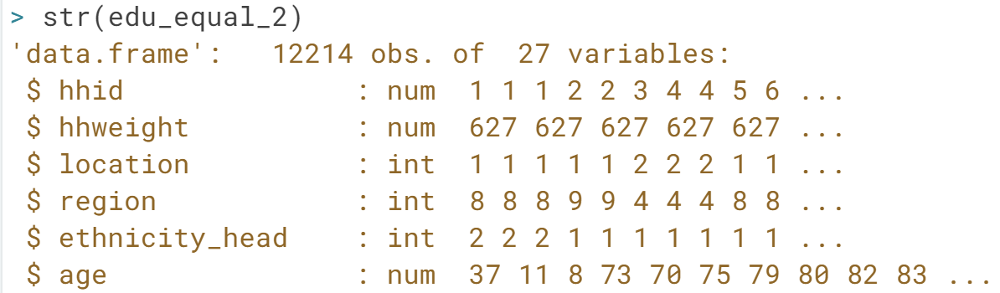

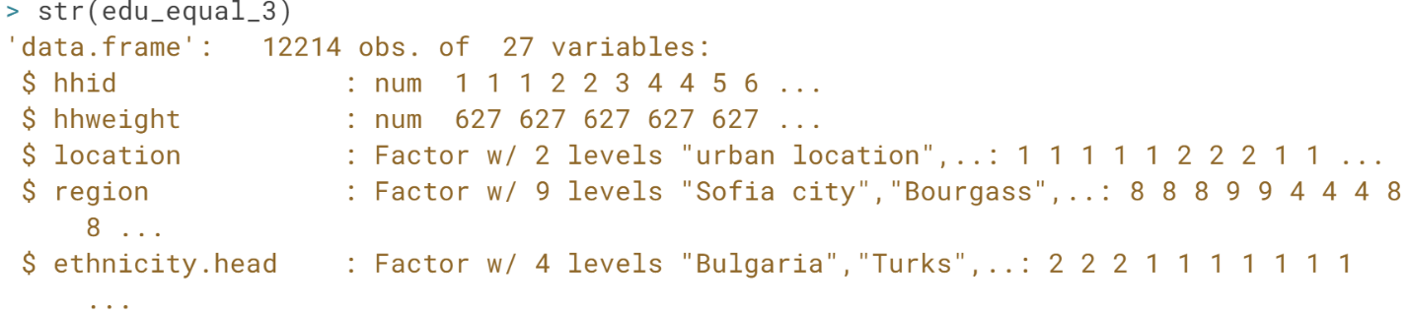

Great! Can you tell the difference between the different versions of ***read.dta()***? For this data, the first version (where you simply specified the file path) will be most useful to work with.

# Do you know your data?

The previous exercise dealt about socio-economic indicators and access to education of different individuals. The edu\_equal\_1 dataset that you've built is already available in the workspace. Now that you have it in R, it's pretty easy to get some basic insights.

For example, you can ask yourself how many observations (e.g. how many people) have an *age* higher than 40 and are *literate*? When you call

str(edu\_equal\_1)

You'll see that age is an integer, and literate is a factor, with the levels "yes" and "no". The following expression thus answers the question:

nrow(subset(edu\_equal\_1, age > 40 & literate == "yes"))

Up to you to answer a similar question now:

How many observations/individuals of Bulgarian ethnicity have an income above 1000?



Correct. The data frame contains 8997 individuals with a Bulgarian ethnicity whose income is above 1000. Now that you're familiar with importing STATA data, it's time to get your hands dirty with some SPSS data!

# Import SPSS data with foreign (1)

All great things come in pairs. Where foreign provided [**read.dta()**](http://www.rdocumentation.org/packages/foreign/functions/read.dta) to read Stata data, there's also **[read.spss()](http://www.rdocumentation.org/packages/foreign/functions/read.spss" \t "_blank)** to read SPSS data files. To get a data frame, make sure to set to.data.frame = TRUE inside **[read.spss()](http://www.rdocumentation.org/packages/foreign/functions/read.spss" \t "_blank)**.

In this exercise, you'll be working with socio-economic variables from different countries (Source: **[Quantative Data Analysis in Education](http://cw.routledge.com/textbooks/9780415372985/resources/datasets.asp" \t "_blank)**). The SPSS data is in a file called international.sav, which is in your working directory. You can also download it [**here**](http://s3.amazonaws.com/assets.datacamp.com/production/course_1478/datasets/international.sav) if you want to play around with it some more.

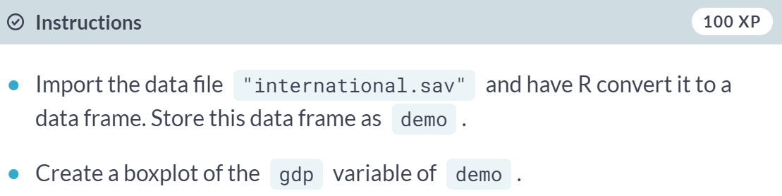

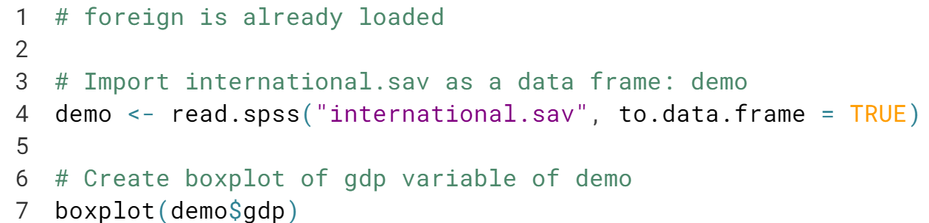

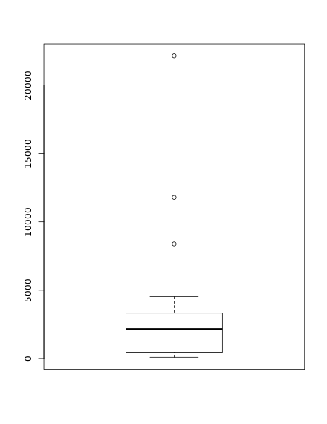

# Excursion: Correlation

If you're familiar with statistics, you'll have heard about Pearson's Correlation. It is a measurement to evaluate the linear dependency between two variables, say XX and YY. It can range from -1 to 1; if it's close to 1 it means that there is a strong positive association between the variables. If XX is high, also YY tends to be high. If it's close to -1, there is a strong negative association: If XX is high, YY tends to be low. When the Pearson correlation between two variables is 0, these variables are possibly independent: there is no association between XX and YY.

You can calculate the correlation between two vectors with the **[cor()](http://www.rdocumentation.org/packages/stats/functions/cor" \t "_blank)** function. Take this code for example, that computes the correlation between the columns height and width of a fictional data frame size:

cor(size$height, size$width)

The data you've worked with in the previous exercise, **[international.sav](http://s3.amazonaws.com/assets.datacamp.com/production/course_1478/datasets/international.sav" \t "_blank)**, is again available in your working directory. It's now up to import it and undertake the correct calculations to answer the following question:

What is the correlation coefficient for the two numerical variables *gdp* and *f\_illit* (female illiteracy rate)?



Correct. The value of the correlation coefficient is equal to -0.4476856, to be precise. That indicates a negative association among GDP and female illiteracy.

# Import SPSS data with foreign (2)

In the previous exercise, you used the to.data.frame argument inside **[read.spss()](http://www.rdocumentation.org/packages/foreign/functions/read.spss" \t "_blank)**. There are many other ways in which to customize the way your SPSS data is imported.

In this exercise you will experiment with another argument, use.value.labels. It specifies whether variables with value labels should be converted into R factors with levels that are named accordingly. The argument is TRUE by default which means that so called labelled variables inside SPSS are converted to factors inside R.

You'll again be working with the **[international.sav](http://s3.amazonaws.com/assets.datacamp.com/production/course_1478/datasets/international.sav" \t "_blank)** data, which is available in your current working directory.

